AWS Advanced Networking Specialty.

Create a VPC (Dual Stack) with Public and Private subnet and deploy ec2 in public and private subnets and enable communication to internet for both instances using IGW and NGW.  
  
VPC:

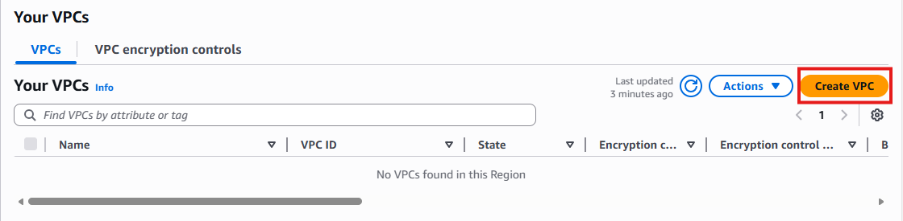  
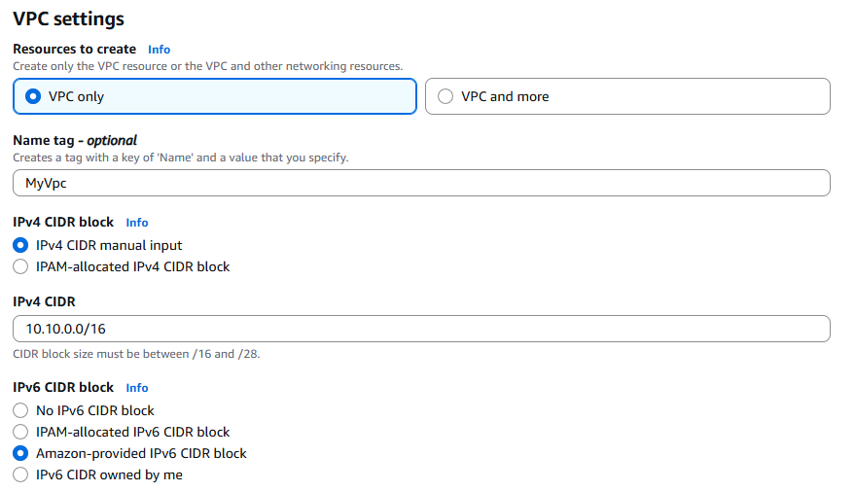  
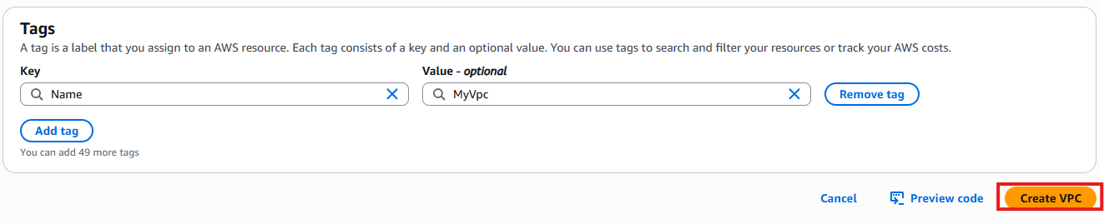

Subnets: Public subnet with IPv4 and Private with both IPv4 & IPv6  
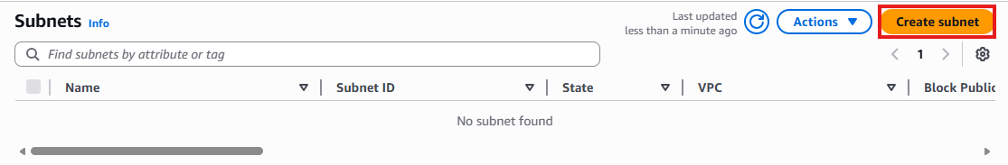  
  
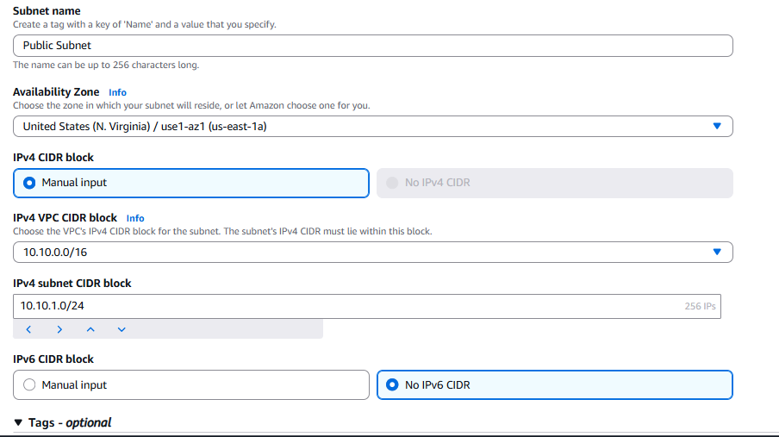  
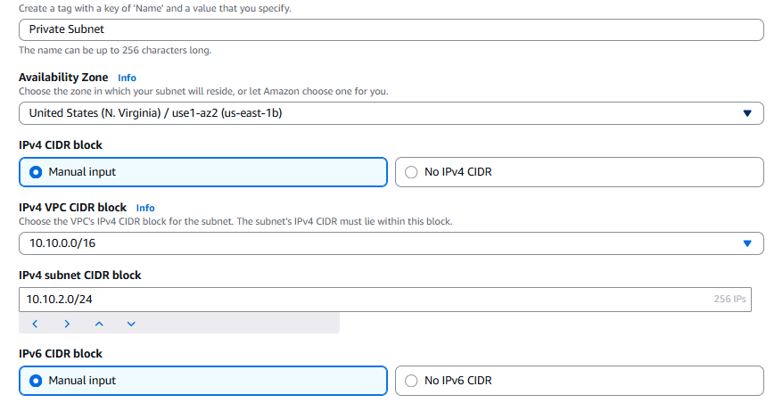  
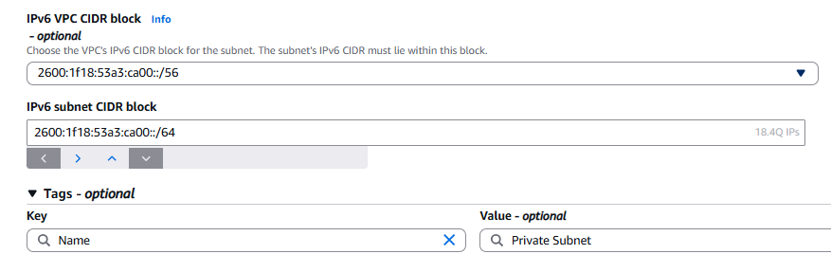  
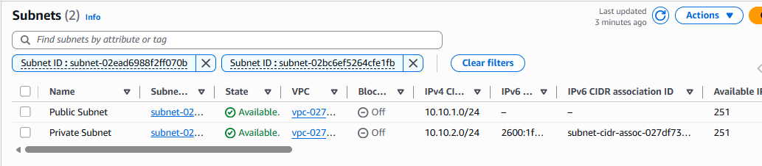  
Internet Gateway:  
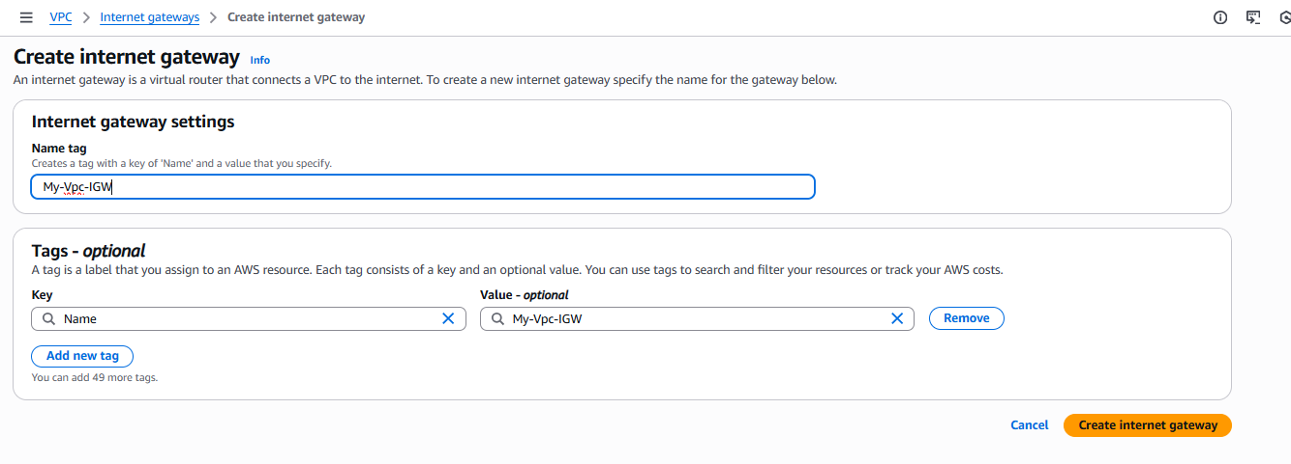  
Route Tables  
Public Subnet Route table and association  
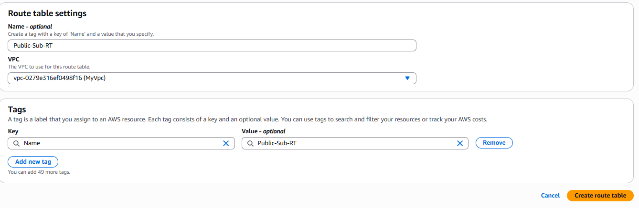  
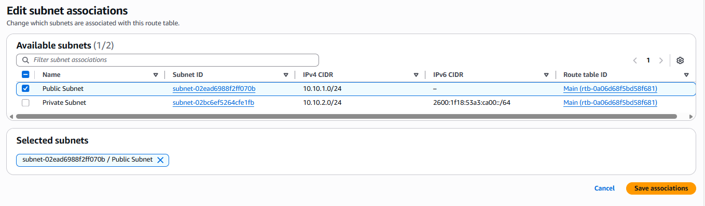  
Create route to internet to make it public  
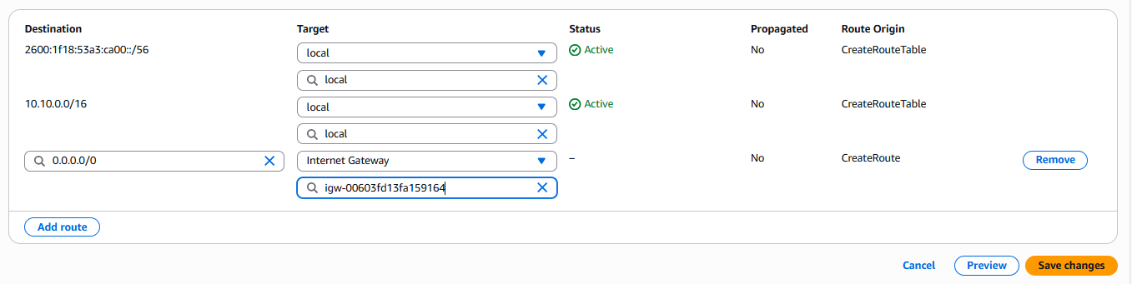  
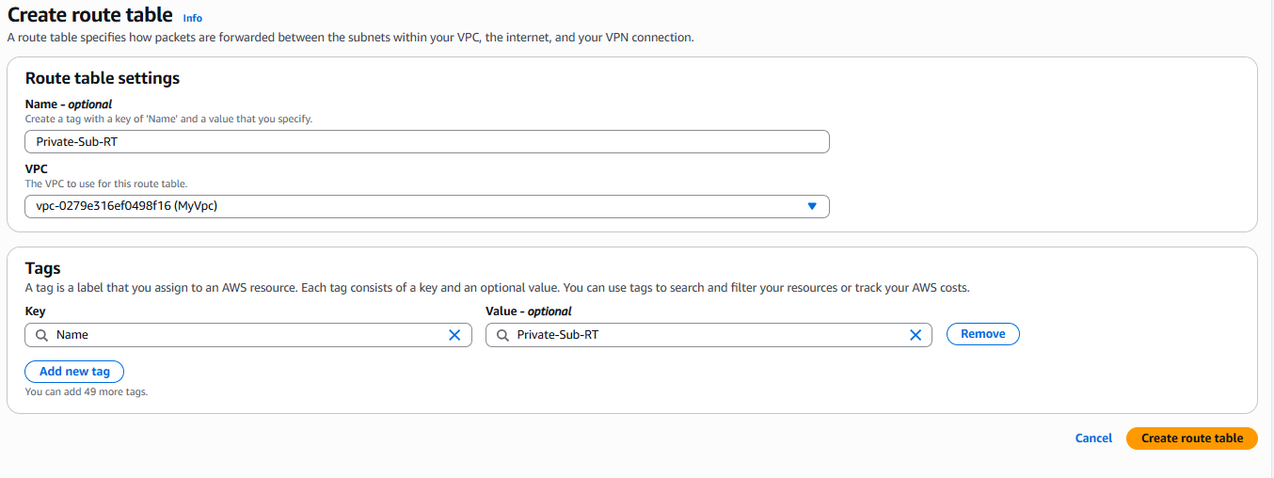  
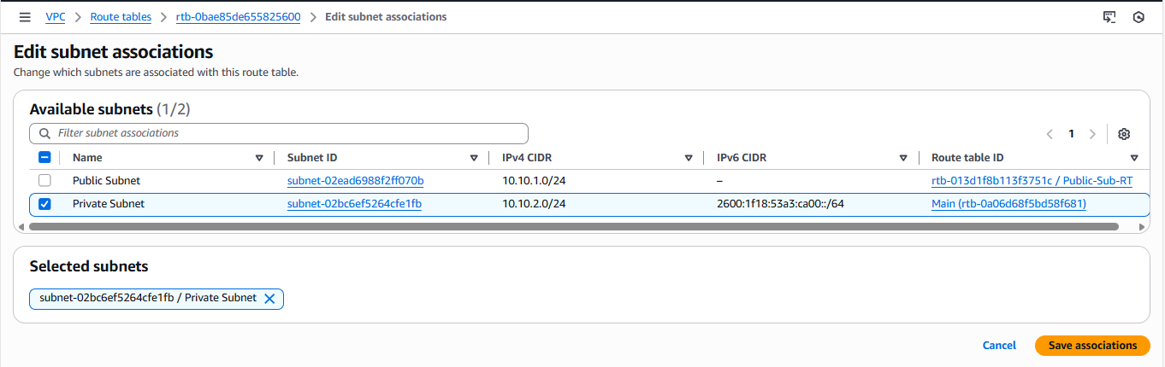  
  
  
  
Attach IGW to VPC  
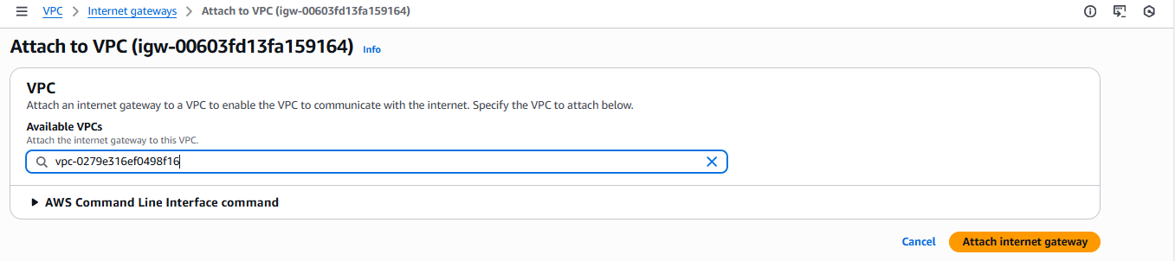  
Cli commands to attach:  
aws ec2 attach-internet-gateway --vpc-id "vpc-0279e316ef0498f16" --internet-gateway-id "igw-00603fd13fa159164" --region us-east-1

Launch two Instances one in public subnet and one in private subnet.  
Instance in public subnet  
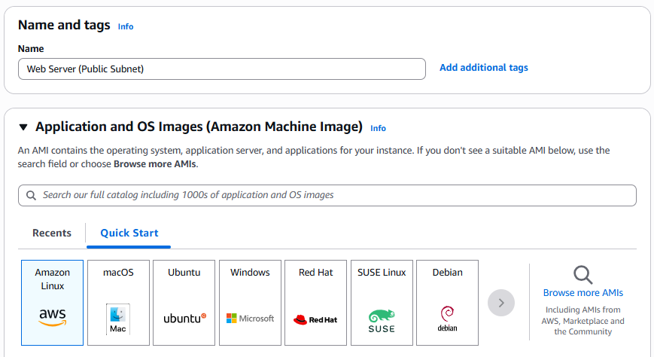  
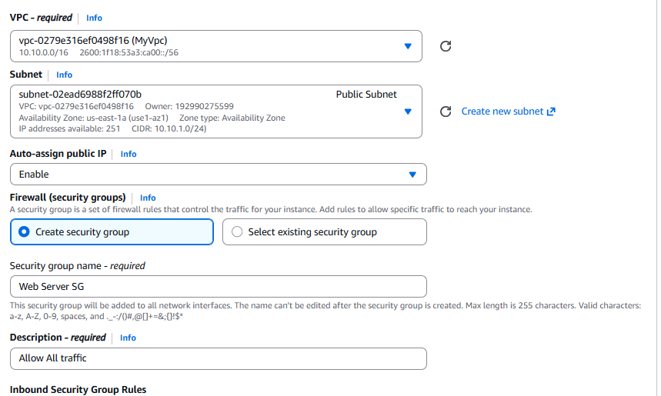  
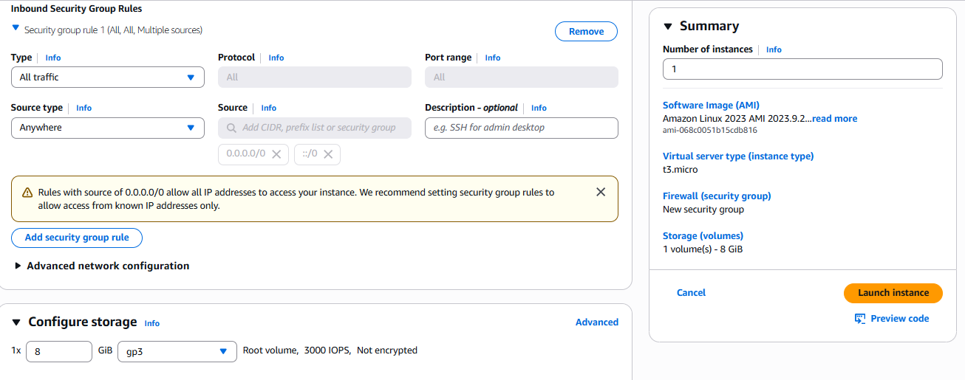  
Instance in private subnet:  
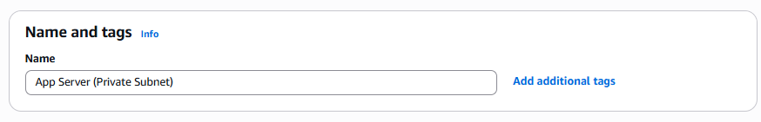  
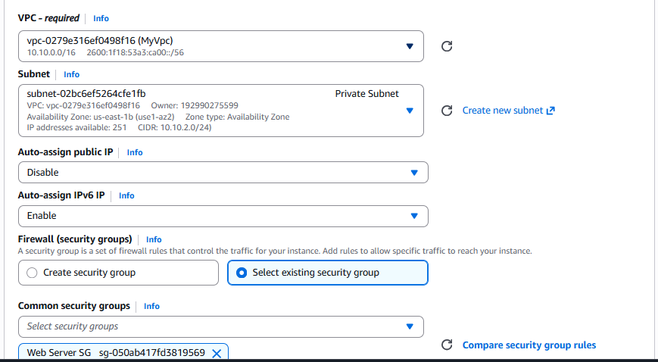  
Check connectivity towards internet.  
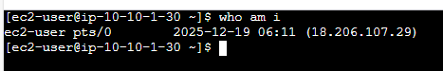  
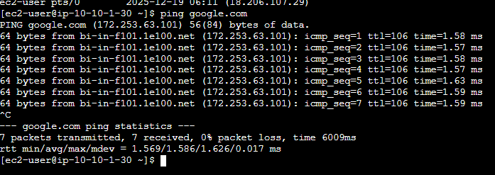  
We cannot connect to private instance from internet as there is no route to internet in private subnet.  
We will connect from public instance to private instance. For that first copy keypair to public instance and then connect to private instance

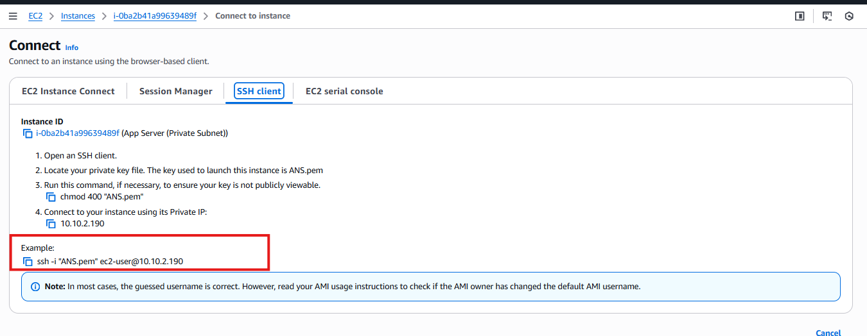

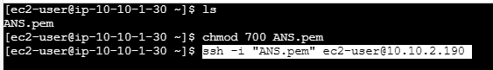

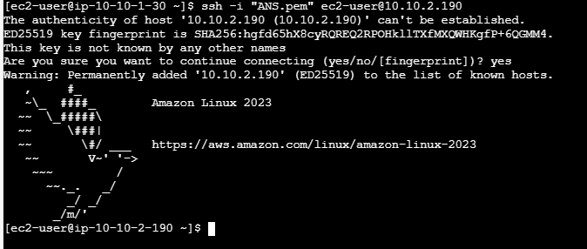

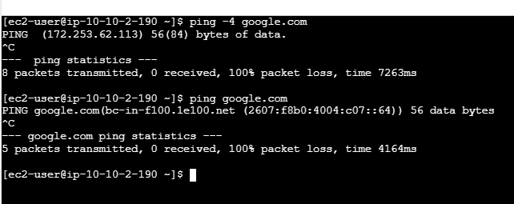

We cannot ping as there is no route to internet in private subnet and we want to keep it such way to protect resources in private subnet, but we want outbound internet connection to resources in private subnet, which can be achieved by NAT Gateway.  
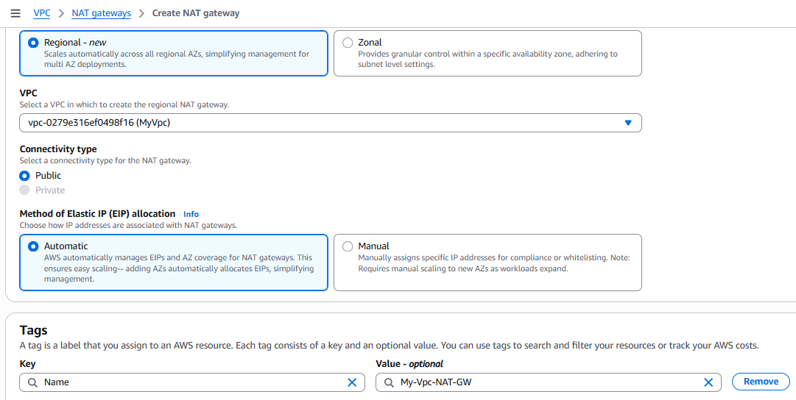  
Add a route in private subnet to forward internet traffic to NAT Gateway.

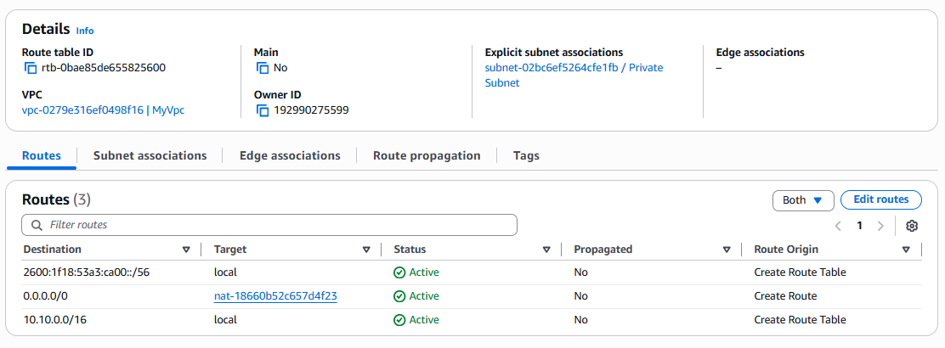  
Now try connecting to internet from ec2 instance in private subnet.  
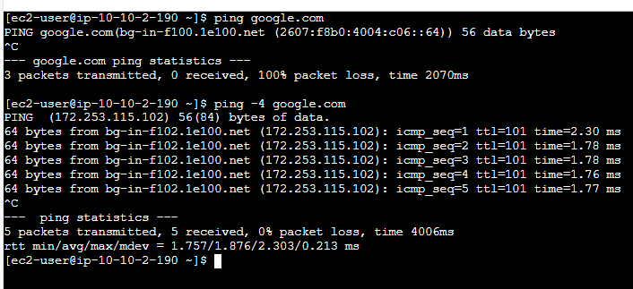  
Here if we see ping is not working on ipv6 but working on ipv4 this is because NAT gateway enables communication between ipv4 to ipv6.  
For ipv6 to work we need to use Egress-Only Internet Gateway.  
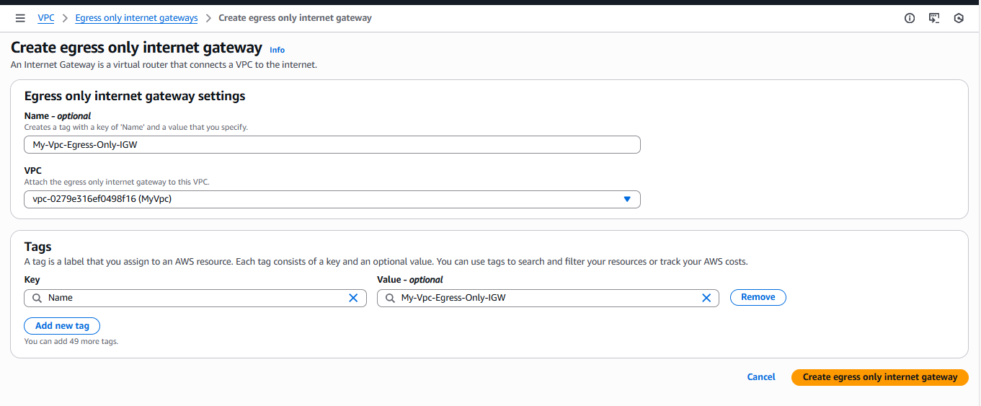  
Add route in private subnet route table to point the ipv6 internet traffic to eigw  
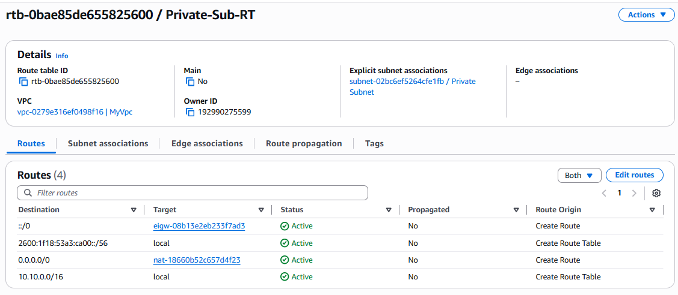  
Now try connecting to internet again.  
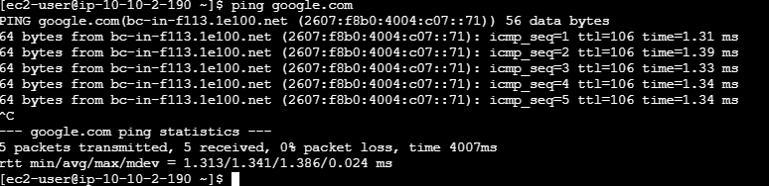  
Now we can see that the traffic to internet form ipv6 also works in private subnet.

------------------------------------------------------------------------------------------------------------------

MTU Test for EC2 Instances.  
  
Launch two instances in public subnet, check mtu using both public and private ips and check mtu on ec2 instance.  
  
Launch two Instances:  
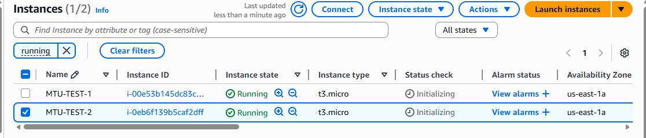  
Connect to one of the instance using public Ip or instance connect.  
tracepath <public ip>  
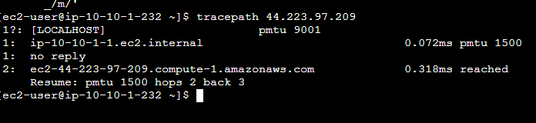  
Here initially it started with mtu 9001 but as it is going through internet its reduced to 1500  
  
tracepath <private ip>  
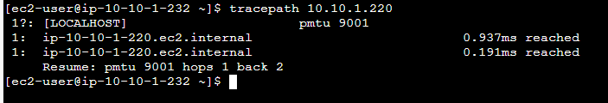  
Now in the second scenario it is routing internally in vpc the final mtu is still 9001.

Check MTU on ec2 interface.  
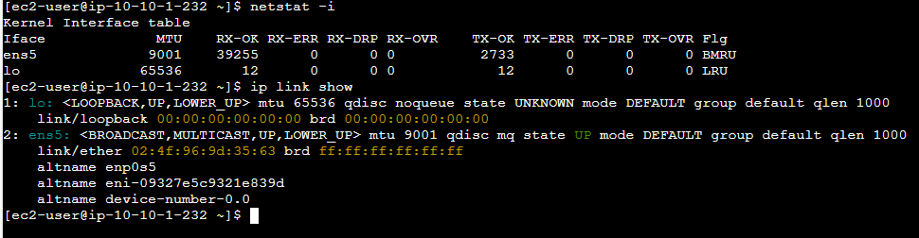

------------------------------------------------------------------------------------------------------------------

VPC Peering across AWS Regions.  
  
Create a VPC in Mumbai Region.

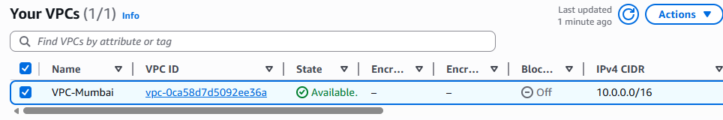

Create a VPC in Oregon.

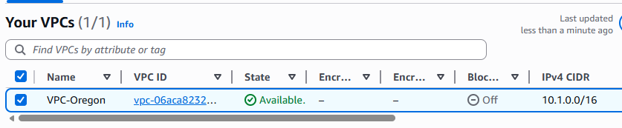  
Launch two instances, one in Mumbai (Public) and one in Oregon (Private).  
  
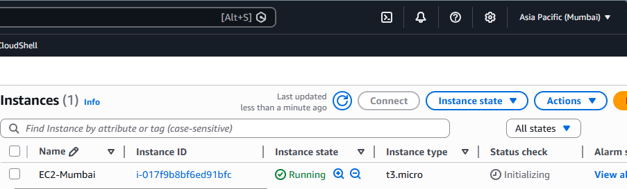  
  
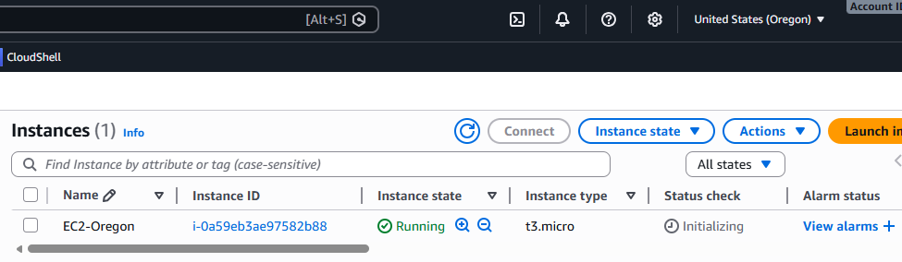

Create peering connection from one of the VPC.

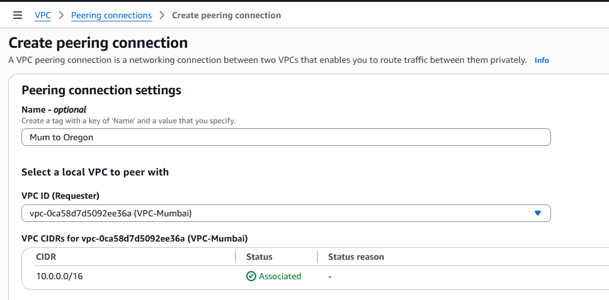

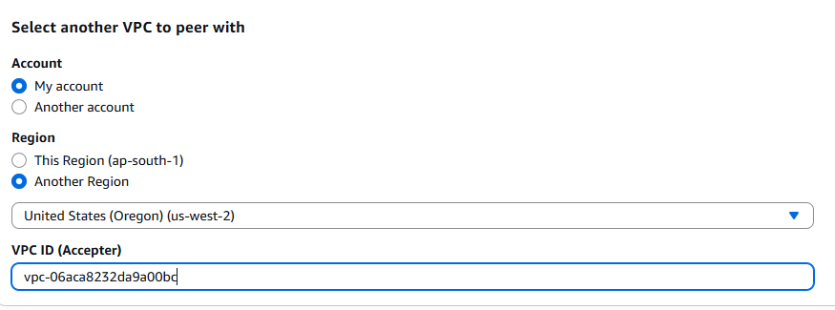

Click on Create peering connection at the bottom.

Now accept the peering connection from Oregon region.

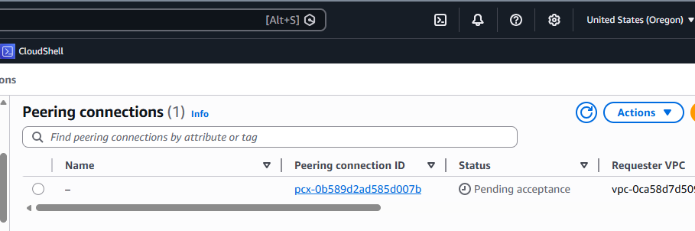

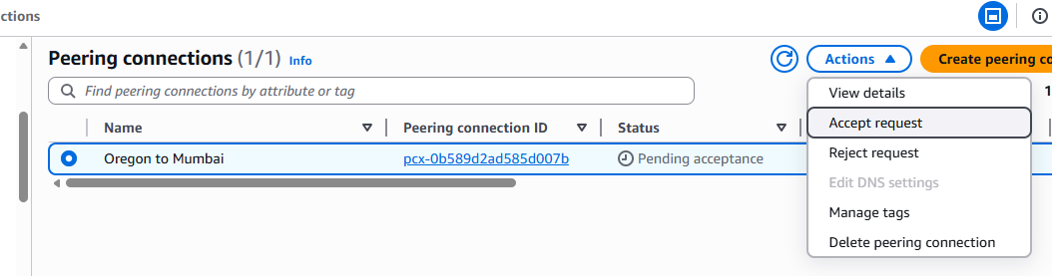

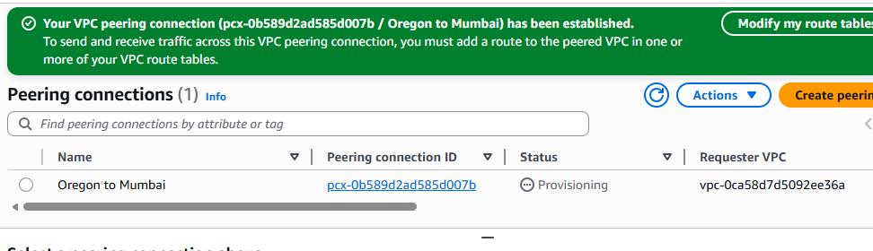

Once peering becomes active we need to change the vpc route tables (Custom RT if any) to enable communication.

Oregon to Mumbai RT

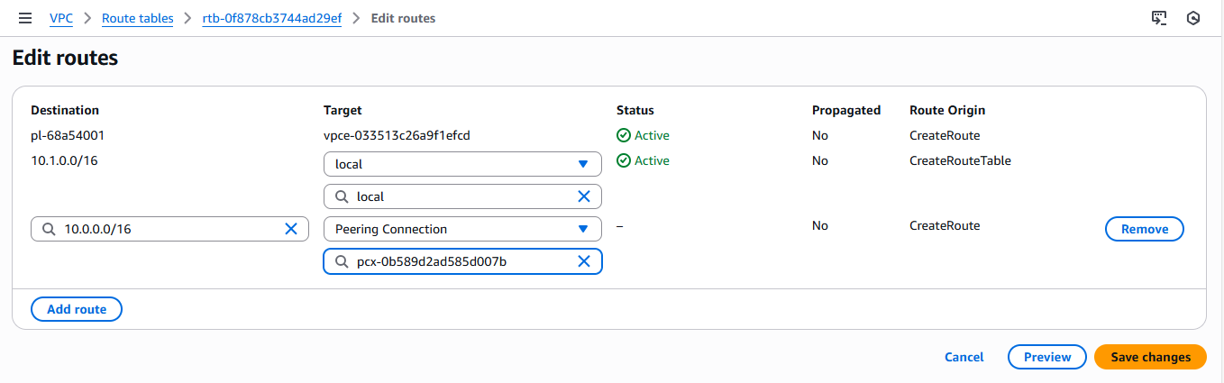

Mumbai to Oregon RT

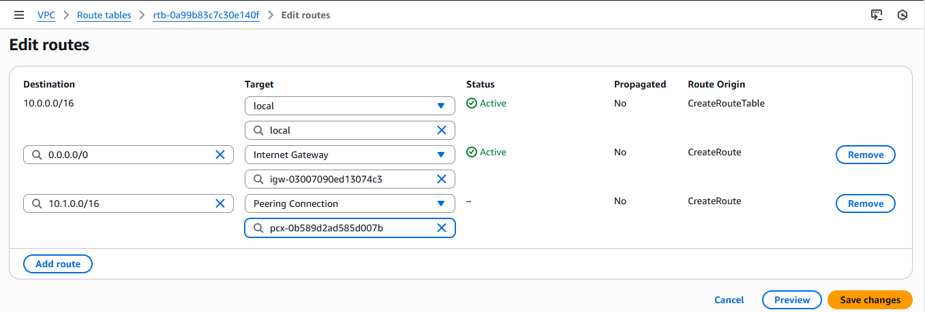

Now evaluate connectivity between two VPC using private ips.  
Mumbai to Oregon

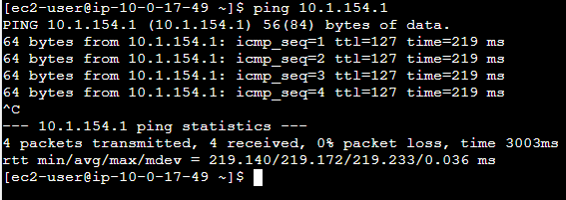

Oregon to Mumbai

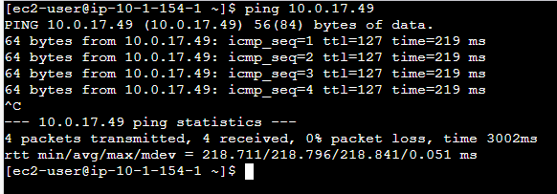

Now we have successfully enabled communication between two VPC in inter regions.

Clean up the resources.

------------------------------------------------------------------------------------------------------------------

ENDPOINTS:

A VPC endpoint is like a private tunnel that connects your AWS resources directly to AWS services without going through the internet.

Key benefits:

* More secure - Traffic never leaves AWS's internal network.
* Faster - No internet route delays.
* Cost-effective - Reduces data transfer charges through NAT gateways.
* Resolute - No dependency on internet connectivity

Two main types:

1. Interface endpoints - Create a network interface in your subnet (for most AWS services)
2. Gateway endpoints - Route traffic through route tables (for S3 and DynamoDB)

#### Gateway Endpoints Demo:

As we are demonstrating Gateway endpoint, we might need to deploy a bastion host to connect to private ec2 and then to s3 service, but AWS recently introduced a way to connect to private ec2 instances from console, which is done using EC2 Instance connect Endpoint, we will leverage this to connect to private ec2.

Architecture

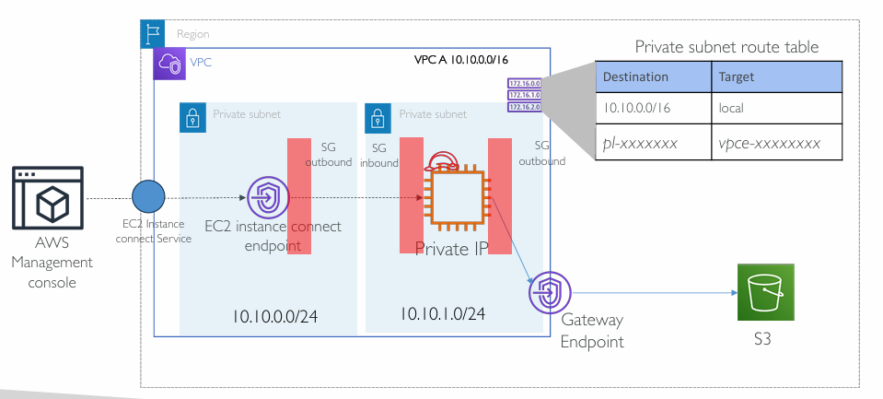

Steps:

1. Create VPC with two private subnets - Subnet1 for EC2Instance endpoint and Subnet2 for EC2 instance.
2. Create Security group for EC2 instance - Inbound to allow SSH (22) and Outbound to allow HTTPS (443)
3. Create Security group for EC2 instance connect endpoint – Outbound to allow SSH (22) to EC2 instance.
4. Create IAM role for EC2 instance to allow S3Full permissions.
5. Launch EC2 instance in subnet2 – Associate SG and IAM role.
6. Create EC2 instance connect endpoint in subnet1 – Associate SG
7. Create VPC Gateway endpoint for S3 - Select Subnet1
8. Modify Subnet2 route table to route traffic to S3 via VPC gateway endpoint.
9. Login to EC2 instance using EC2 instance connect choice from AWS console.
10. Evaluate the connectivity to S3 by uploading/downloading some files.

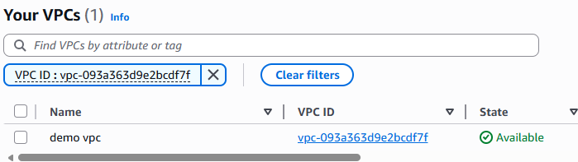

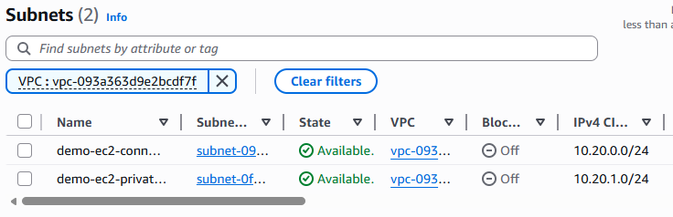

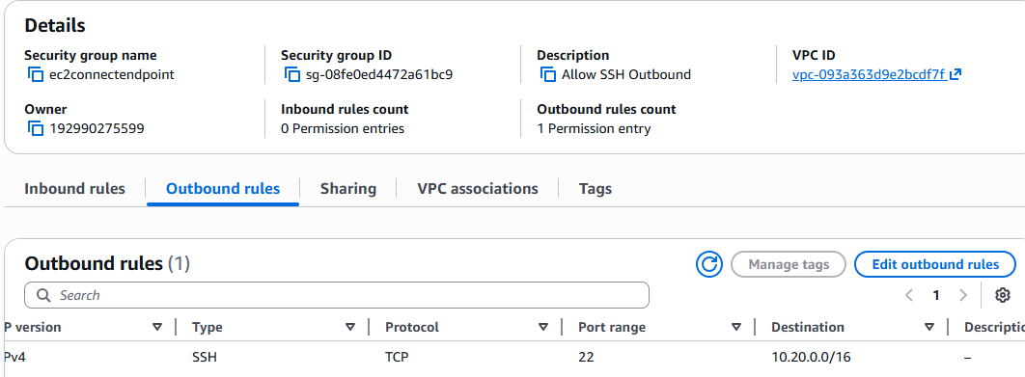

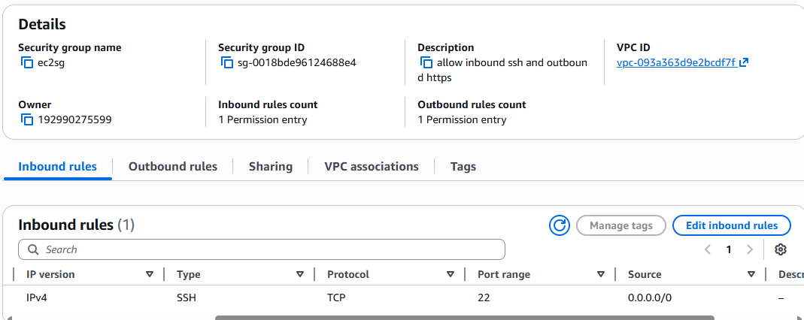

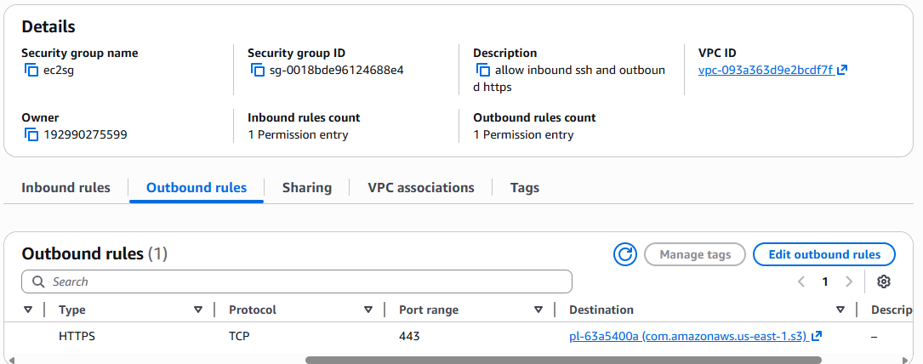

Create endpoint.

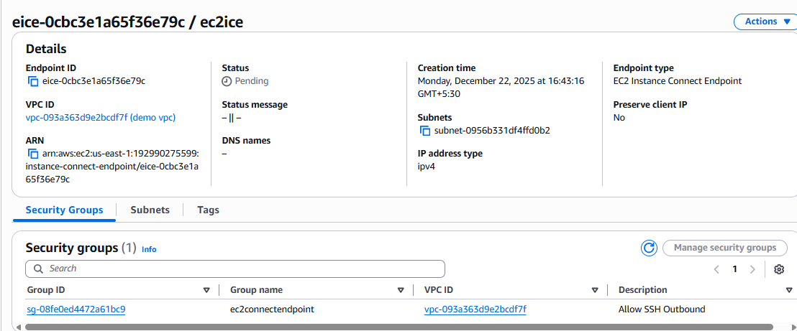

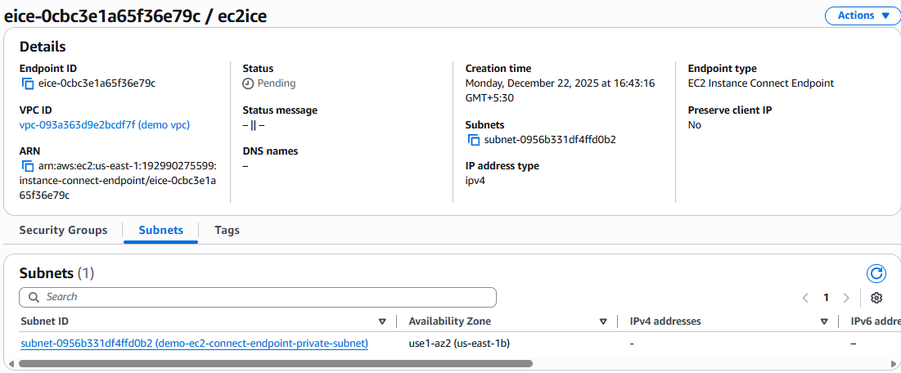

Create an iam role for ec2 with s3 full access.

Create an instance in another subnet and attach the iam role created.

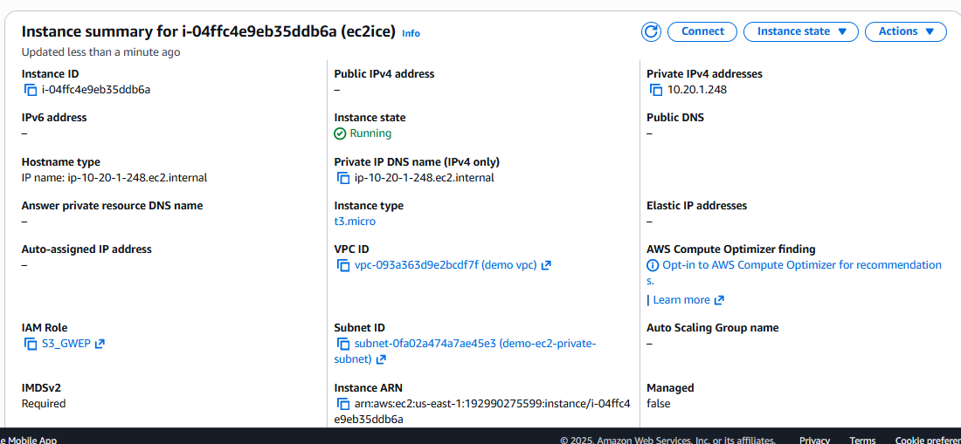

Connect to instance using instance connect endpoint using private ip.

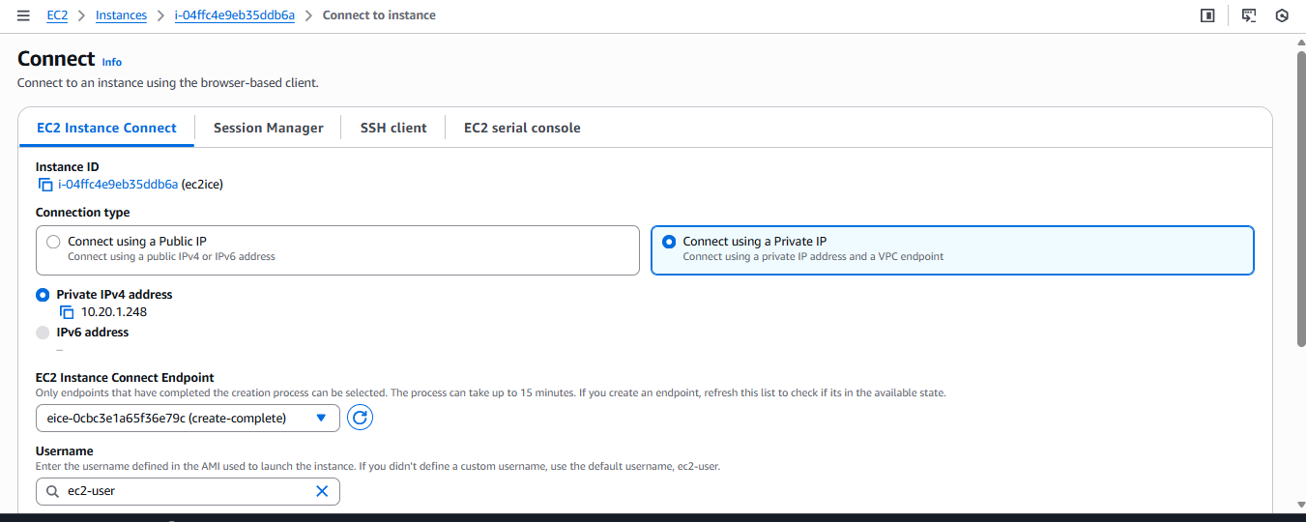

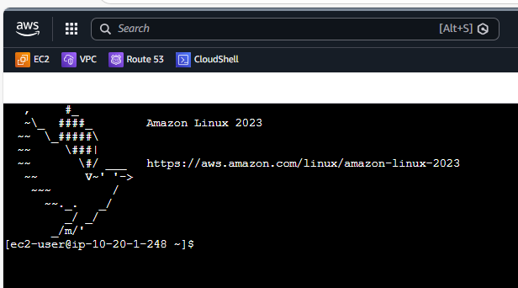

Create and sample s3 bucket to evaluate the gateway endpoint.

Create a gateway endpoint.



Try and upload a sample file to s3 bucket.

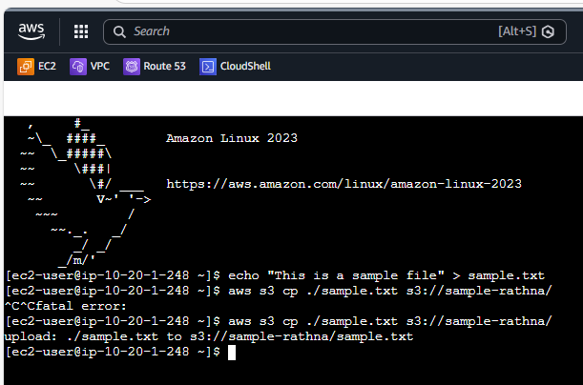

Verify the objects.

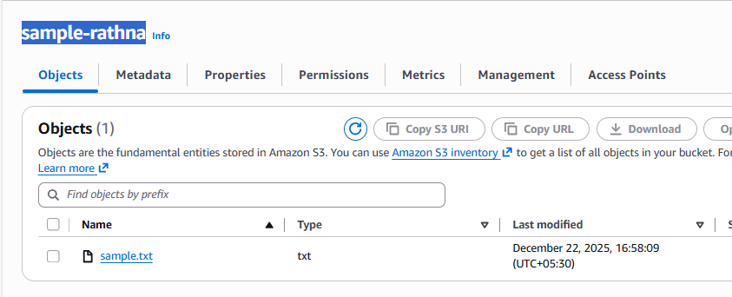

------------------------------------------------------------------------------------------------------------------

#### EC2 Instance Connect Lab Demo (Only EICE Lab)

**Step 1: Create VPC Infrastructure**

**1.1 Create a VPC:**

* Go to **VPC Console** → **Create VPC**
* Choose **"VPC only"**
* **Name:** "MyVPC"
* **IPv4 CIDR:** 10.0.0.0/16
* Click **Create VPC**

**1.2 Create a Private Subnet:**

* Go to **Subnets** → **Create subnet.**
* **VPC:** Select "MyVPC"
* **Subnet name:** "PrivateSubnet"
* **Availability Zone:** Choose any (e.g., us-east-1a)
* **IPv4 CIDR:** 10.0.1.0/24
* Click **Create subnet.**

**Step 2: Create Security Groups (Before Creating Resources)**

**2.1 Create Security Group for EC2 Instance Connect Endpoint:**

* Go to **VPC Console** → **Security Groups** → **Create security group.**
* **Security group name:** "EICE-SecurityGroup"
* **Description:** "Security group for EC2 Instance Connect Endpoint"
* **VPC:** Select "MyVPC"
* **Outbound rules:** (We'll configure this after creating the EC2 security group)
  + Keep default "All traffic" for now.
* Click **Create security group.**
* **Note the Security Group ID** (e.g., sg-0123456789abcdef0)

**2.2 Create Security Group for EC2 Instance:**

* Go to **Security Groups** → **Create security group.**
* **Security group name:** "EC2-Instance-SecurityGroup"
* **Description:** "Security group for EC2 instance"
* **VPC:** Select "MyVPC"
* **Inbound rules:**
  + **Type:** SSH
  + **Protocol:** TCP
  + **Port range:** 22
  + **Source:** Custom → Select "EICE-SecurityGroup" (sg-0123456789abcdef0)
* **Outbound rules:** Keep default "All traffic."
* Click **Create security group.**
* **Note the Security Group ID** (e.g., sg-0987654321fedcba0)

**2.3 Update EICE Security Group Outbound Rules:**

* Go back to **"EICE-SecurityGroup.”**
* Click **Edit outbound rules.**
* **Delete the default "All traffic" rule.**
* **Add new rules:**
  + **Type:** SSH
  + **Protocol:** TCP
  + **Port range:** 22
  + **Destination:** Custom → Select "EC2-Instance-SecurityGroup" (sg-0987654321fedcba0)
* Click **Save rules.**

**Step 3: Launch EC2 Instance in Private Subnet**

**3.1 Launch Instance:**

* Go to **EC2 Console** → **Launch Instance**
* **Name:** "MyPrivateInstance"
* **AMI:** Amazon Linux 2023 AMI
* **Instance type:** t2.micro (free tier eligible)
* **Key pair:** Create new or select existing key pair.

**3.2 Network Settings:**

* **VPC:** Select "MyVPC"
* **Subnet:** Select "PrivateSubnet"
* **Auto-assign public IP:** **Disable**
* **Firewall (security groups):** Select existing security group.
* **Security groups:** Select "EC2-Instance-SecurityGroup."

**3.3 Storage and Advanced Details:**

* Keep default storage settings.
* Click **Launch instance.**
* **Note the Instance ID** (e.g., i-0123456789abcdef0)

**Step 4: Create EC2 Instance Connect Endpoint**

**4.1 Using AWS Console:**

* Navigate to **VPC Console**
* In left navigation, click **"Endpoints."**
* Click **"Create endpoint"**

**4.2 Configure the Endpoint:**

* **Name tag:** "MyEICE.”
* **Service category:** Choose **"EC2 Instance Connect Endpoint.”**
* **VPC:** Select "MyVPC"
* **Preserve Client IP:**
  + ❌ **Uncheck** (recommended for simplicity)
  + This means the endpoint's IP will be the source, not your client IP.
* **Security Groups:** Select "EICE-SecurityGroup"
* **Subnet:** Select "PrivateSubnet"
* Click **"Create Endpoint"**

**4.3 Using AWS CLI (Alternative):**

|  |
| --- |
| aws ec2 create-instance-connect-endpoint \ |
| --region us-east-1 \ |
| --subnet-id subnet-0123456789example \ |
| --security-group-ids sg-0123456789abcdef0 \ |
| --preserve-client-ip false |

Run in CloudShell

**4.4 Wait for Endpoint Creation:**

* **Initial status:** "create-in-progress."
* **Wait until status becomes:** "create-complete" (usually 2-5 minutes)
* **Note the Endpoint ID** (e.g., eice-0123456789example)

**Step 5: Verify Security Group Configuration**

**5.1 Verify EICE Security Group:**

* **Outbound rules should have:**
  + Type: SSH, Port: 22, Destination: EC2-Instance-SecurityGroup

**5.2 Verify EC2 Instance Security Group:**

* **Inbound rules should be:**
  + Type: SSH, Port: 22, Source: EICE-SecurityGroup

**Step 6: Connect to EC2 Instance Using Private IP**

**6.1 Using AWS Console:**

1. Go to **EC2 Console**
2. Select your **EC2 instance** ("MyPrivateInstance")
3. Click **"Connect"**
4. Choose **"EC2 Instance Connect"** tab.
5. Configure connection:
   * **Connection type:** Select **"Connect using a Private IP."**
   * **IP address type:** Choose **"Private IPv4 address."**
   * **EC2 Instance Connect Endpoint:** Select your endpoint ID (eice-0123456789example)
   * **Username:**

ec2-user

 (for Amazon Linux)

* + **Max tunnel duration:** 3600 seconds (1 hour max)

1. Click **"Connect"**

**6.2 Using AWS CLI with SSH:**

|  |
| --- |
| # Step 1: Open tunnel (keep this terminal open) |
| aws ec2-instance-connect open-tunnel \ |
| --instance-id i-0123456789abcdef0 \ |
| --instance-connect-endpoint-id eice-0123456789example \ |
| --remote-port 22 \ |
| --local-port 8888\ |
| --region us-east-1 |
|  |
| # Step 2: Connect via SSH (in new terminal) |
| ssh -i /path/to/your-key.pem ec2-user@localhost -p 8888 |

Run in CloudShell

**Step 7: Verify Connection**

Once connected, you should see:

|  |
| --- |
| [ec2-user@ip-10-0-1-xxx ~] $ |

Run in CloudShell

**Verify you are connected via private IP:**

|  |
| --- |
| # Check private IP |
| curl http://169.254.169.254/latest/meta-data/local-ipv4. |
|  |
| # Check if no public IP exists |
| curl http://169.254.169.254/latest/meta-data/public-ipv4. |
| # Should return: 404 - Not Found |

Run in CloudShell

------------------------------------------------------------------------------------------------------------------

#### Accessing AWS Services using AWS VPC endpoints - Interface Endpoints

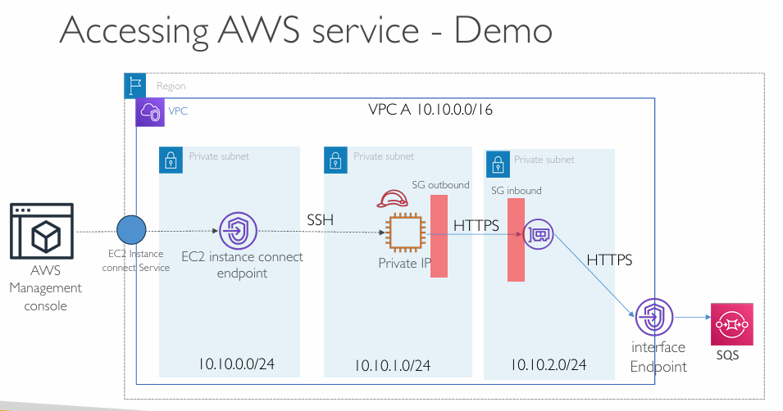

1. Create VPC with three private subnets - Subnet1 for EC2Instance endpoint, Subnet2 for EC2 instance and Subnet 3 for VPC endpoint.
2. Enable DNS hostnames” and “Enable DNS Support for the VPC
3. Create Security group for EC2 instance - Inbound to allow SSH (22) and Outbound to allow HTTPS (443)
4. Create Security group for EC2 instance connect endpoint – Outbound to allow SSH (22) to EC2 instance.
5. Create Security group for VPC endpoint ENI – Inbound HTTPS (443) from EC2 instance.
6. Create IAM role for EC2 instance to allow Amazon SQS permissions.
7. Create EC2 instance connect endpoint in subnet1 – Associate SG
8. Launch EC2 instance in subnet2 – Associate SG and IAM role.
9. Create a test SQS queue.
10. Create VPC interface endpoint for SQS - Select Subnet3, Enable Private DNS
11. Login to EC2 instance using EC2 instance connect choice from AWS console.
12. Evaluate the connectivity to SQS by sending some messages.

As we already have VPC and ec2 instance connect endpoint and VPC deployed in two subnets lets continue with rest.

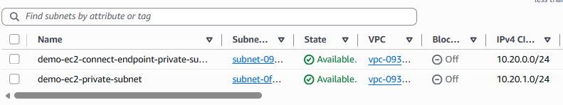

Create one more subnet for Interface endpoint (As per best practices)

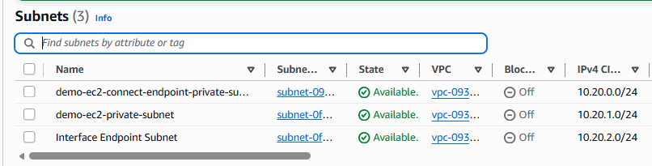

We already have an SG for ec2 instance and an SG for EC2InstanceConnect Endpoint, now we must create one more for interface endpoint.

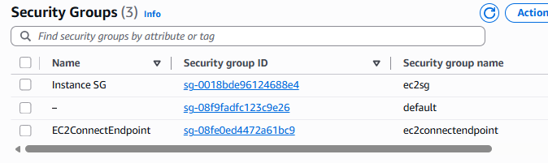

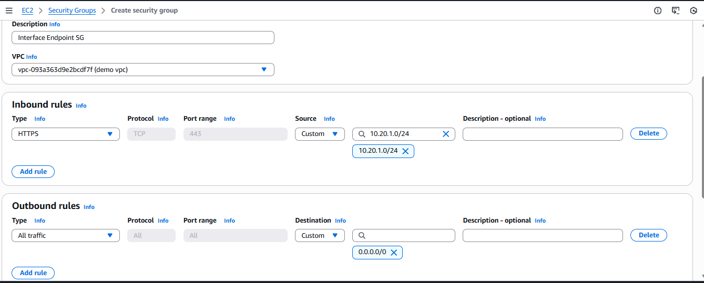

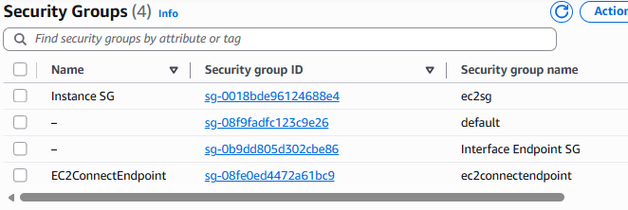

Create an IAM role and attach to our Lab Instance.

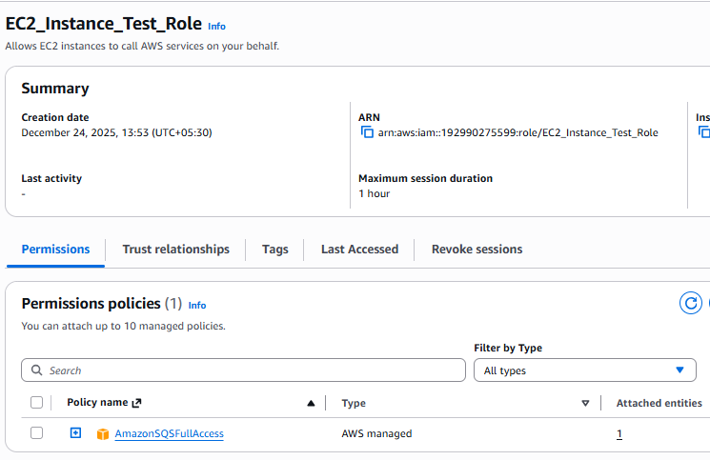

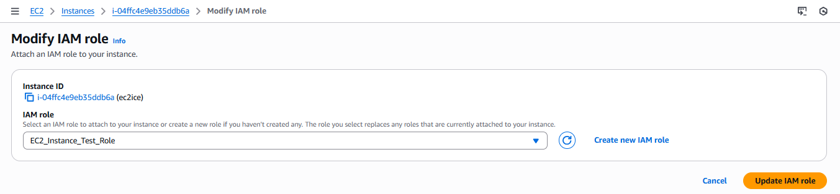

Create a test SQS Service

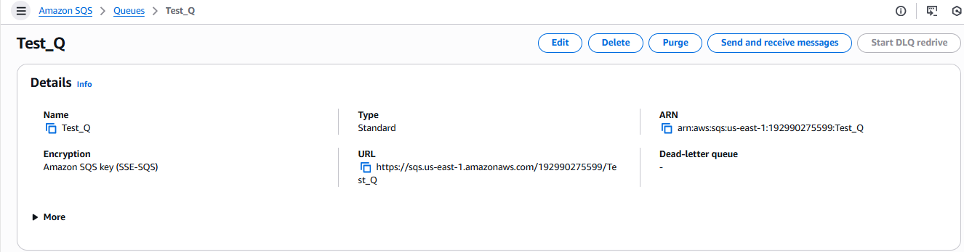  
Create an interface endpoint to access SQS Test_Q.

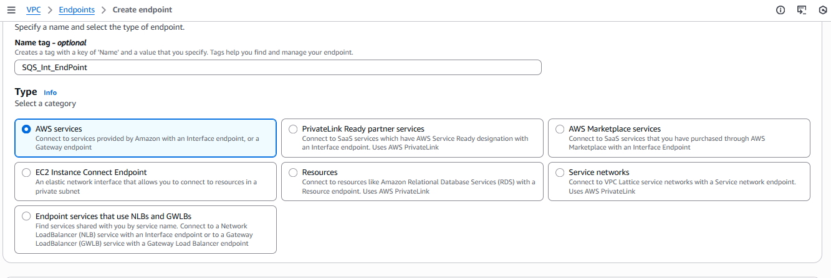

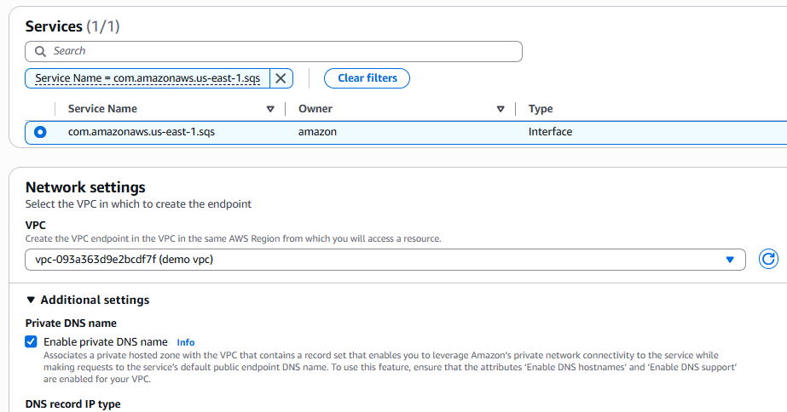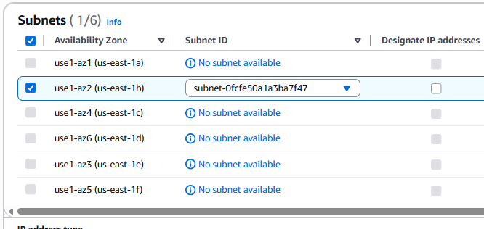

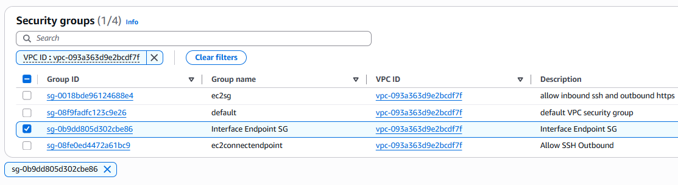

Publish test message to SQS Queue using endpoint.

Command: aws sqs send-message --queue-url <queue url> --message-body "This is a test message" --region us-east-1 --endpoint-url <endpoint url>

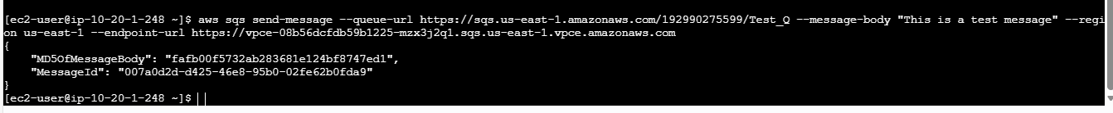

Poll for message in the queue and confirm.

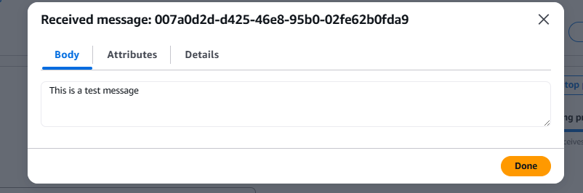

------------------------------------------------------------------------------------------------------------------

#### VPC ENDPOINT SERVICE

To create VPC endpoint service in Service Provider VPC

Choose the Network Load Balancer (+availability zones) and register the targets in the Target group.

Create a VPC endpoint Service.

Choose AWS regions for Cross-region access to the service.

Configure “Require Acceptance” flag.

Optionally configure “Enable Private DNS” – you must own the DNS.

Configure supported IP type – IPv4 or IPv4 or both.

Allow other AWS accounts to access your endpoint service by adding AWS account or Role or User ARN in the “Allow Principals” setting.

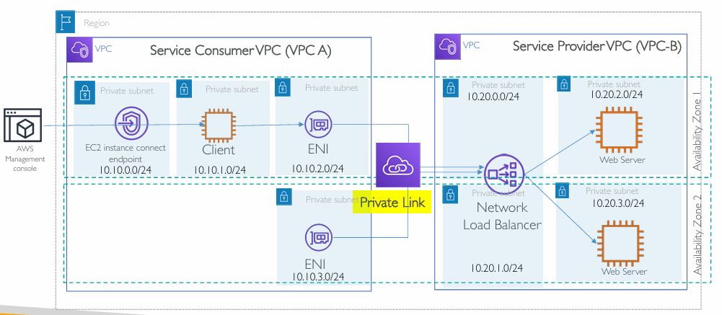

Exercise steps

Pre-requisites: Create EC2 AMI having httpd webserver. We need this to launch Private EC2 instances in VPC-B to host the dummy service.

1. Create VPC-B with 4 Private Subnets – 2 for NLB and 2 for Webserver
2. Launch 2 EC2 instances in Private Subnets using AMI created earlier.
3. Create NLB in 2 Private Subnets and register EC2 instances in Target group.
4. Create VPC Endpoint Service in VPC-B using NLB.
5. Allow the VPC-A AWS account (if both VPCs are in different AWS accounts)
6. Create Service Consumer VPC (VPC-A) with 4 private subnets as shown.
7. Create EC2 instance connect endpoint in the VPC-A in the first private subnet.
8. Launch a consumer EC2 instance in one of the private subnets.
9. Login to Private EC2 instance (via EC2 instance connect endpoint) in VPC-A
10. Create VPC endpoint in VPC-A and search for endpoint service created above.
11. Verify the connectivity to VPC endpoint service (webserver) using zonal and regional endpoints.
12. Optionally enable the Private DNS for the VPC endpoint service and verify the connectivity using private DNS (you must own the domain name and should be able to verify the ownership)

Launch an instance in default vpc and install httpd and create ami for use in NLB.

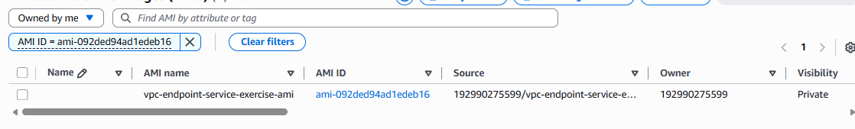

Create Provider VPC with 4 subnets.

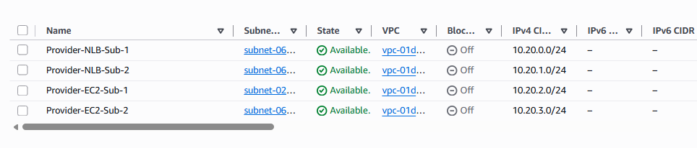

Launch two instances using ami created.

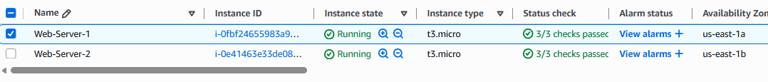

Create NLB and ec2 instances as target.  
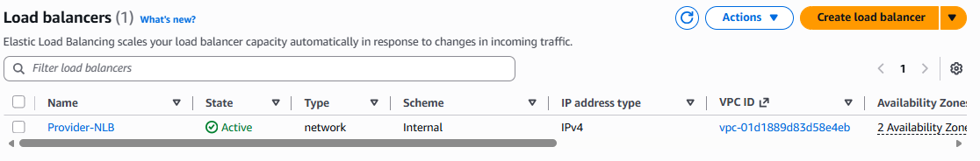

Create Endpoint service for the NLB.

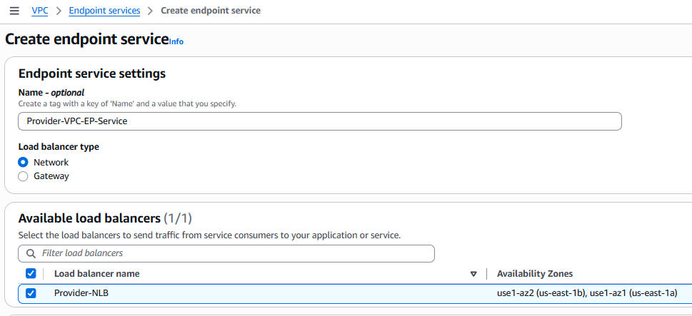

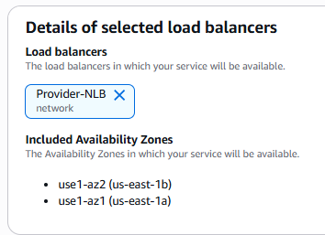

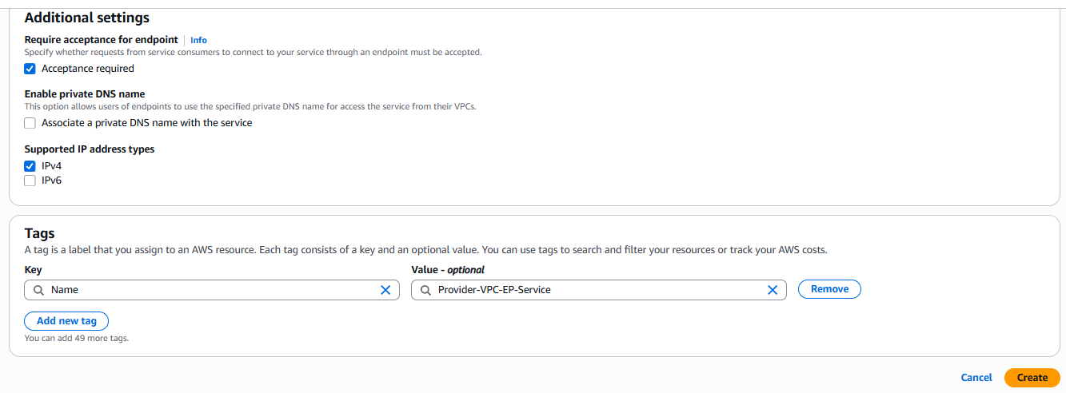

Now we are done with provider vpc and its related configuration and in consumer vpc we already have three subnets in it, we will do next configurations.

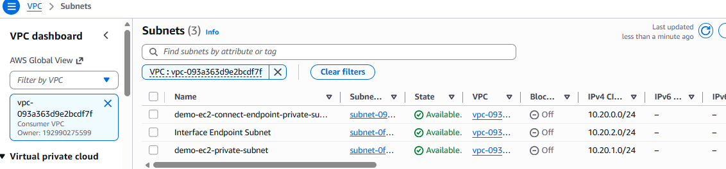

We already have instance connect endpoint and ec2 instance deployed.

Let us create endpoint for consumer vpc.

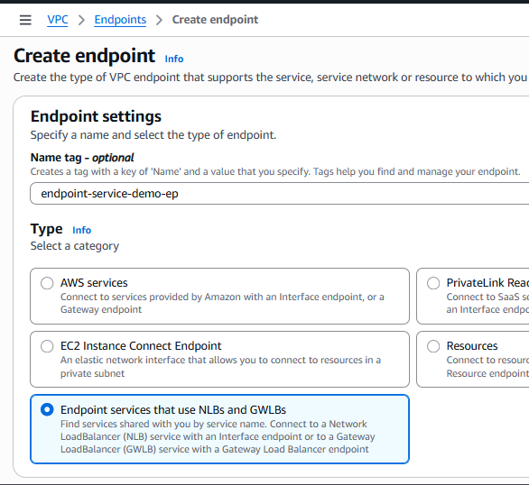

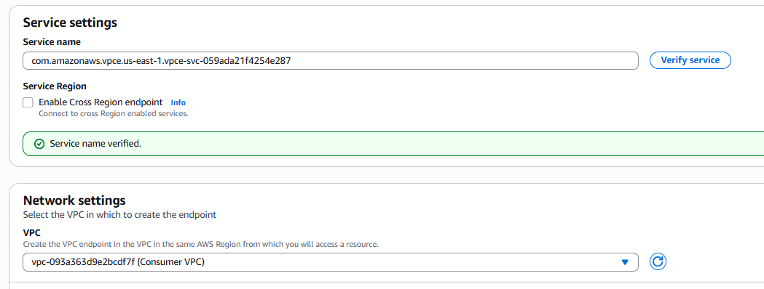

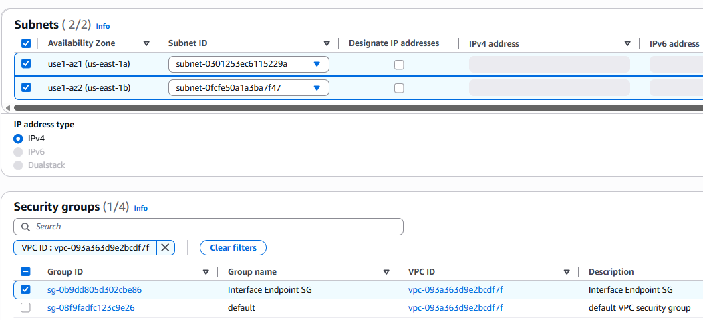

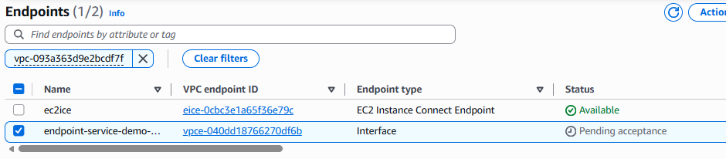

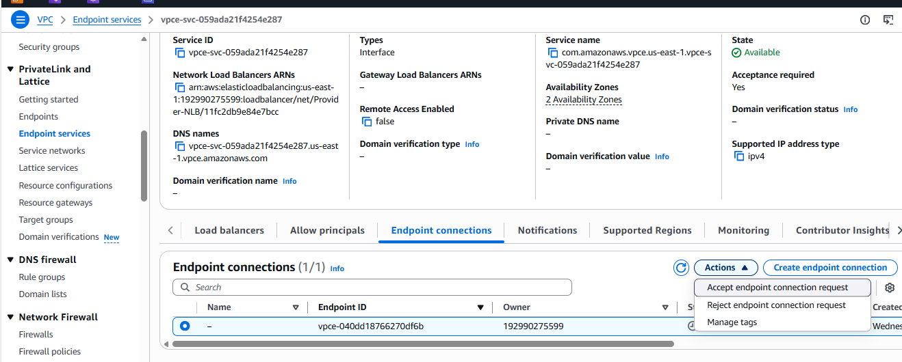

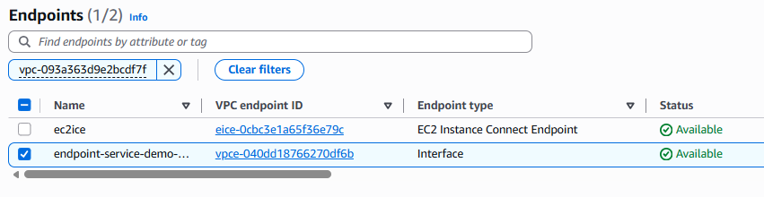

Now as we have done all the configuration, we can evaluate it using our ec2 in consumer vpc.

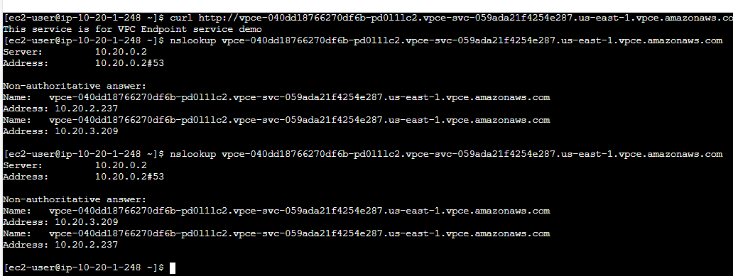

------------------------------------------------------------------------------------------------------------------

#### Enabling communication between multiple VPC’s using Transit Gateway and full routing.

Steps:

1. Create 3 VPCs and corresponding private subnets. For VPC A additionally create a Public Subnet (we need that for jump host).
2. Create Transit Gateway.
3. Create 3 VPC attachments for the Transit Gateway.
4. Modify all Private subnet route table and add route for 10.0.0.0/8 via the Transit gateway attachment.
5. SSH to VPC A Jump host -> SSH to EC2-A -> Ping to EC2-B or EC2 C using a Private IP.

Create 3 VPCs and corresponding private subnets, (One VPC with Public subnet to deploy Jump Server).

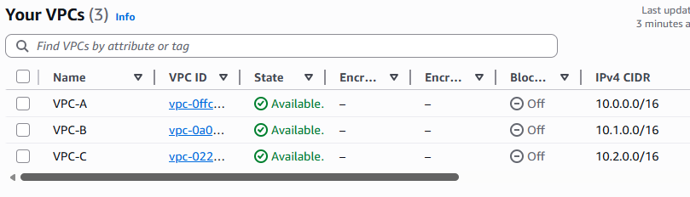

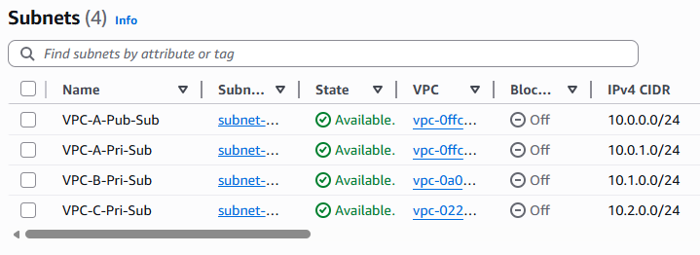

Deploy Instances in All subnets.

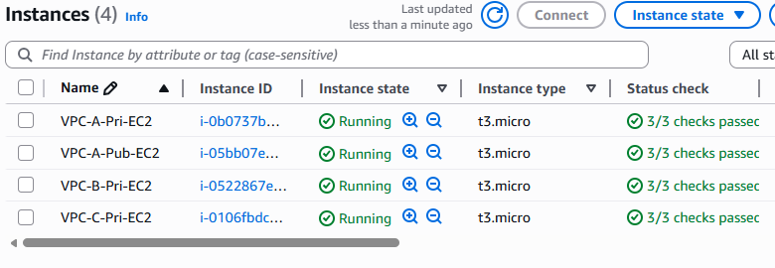

Create Transit Gateway

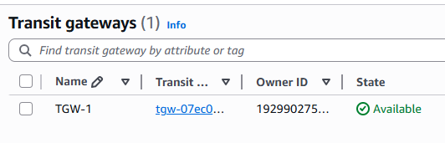

Create VPC attachments for each VPC

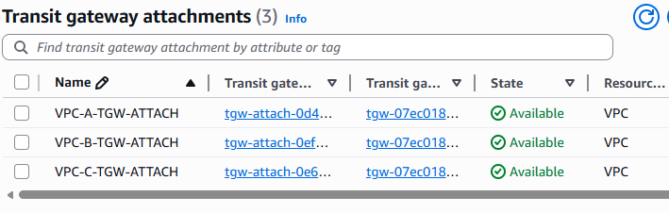

Modify all Private Route Tables to enable communication

VPC-A

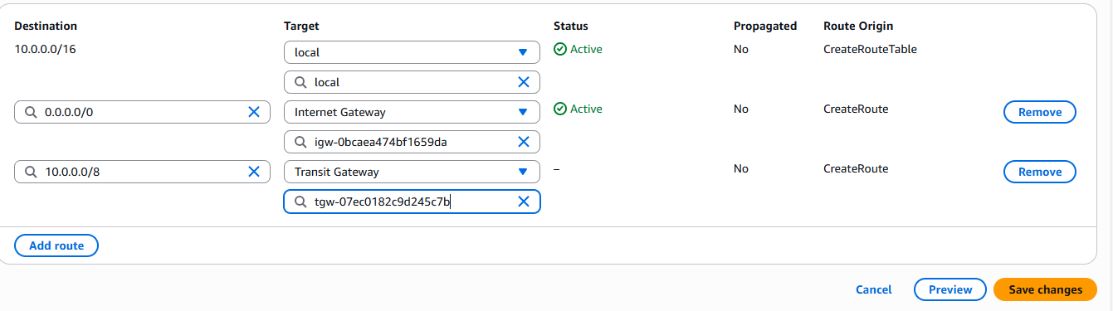

VPC-B

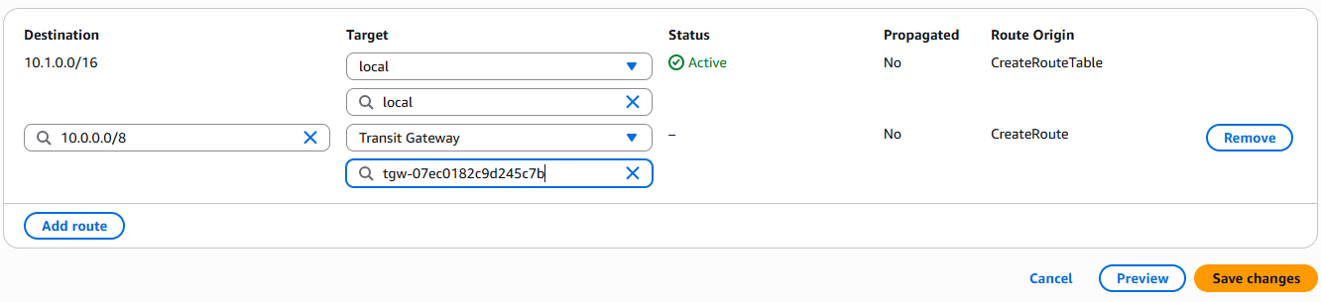

VPC-C

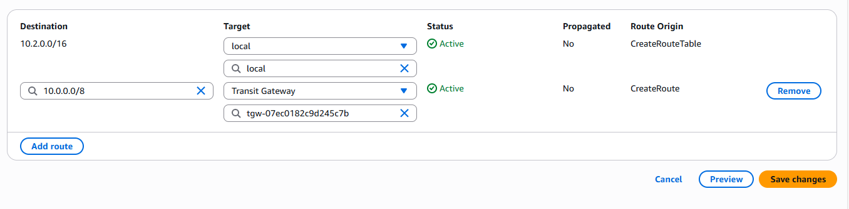

Connect to Private EC2 in VPC A and ping EC2 in VPC B & VPC C

VPC A to VPC B

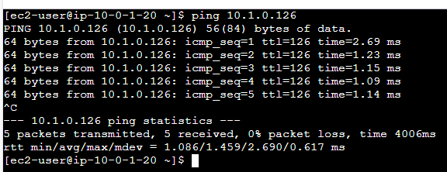

VPC A to VPC C

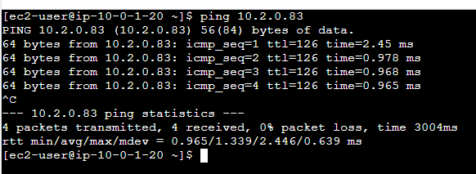

VPC B to VPC A

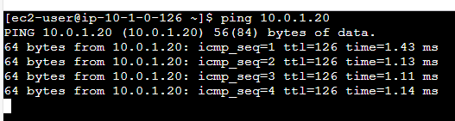

VPC B to VPC C

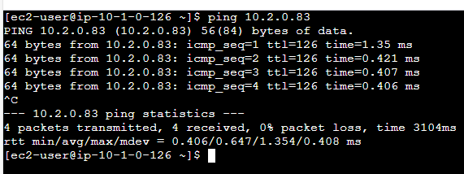

VPC C to VPC A

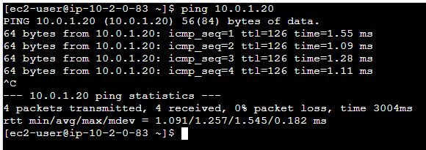

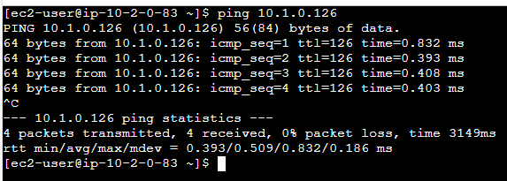

Now we have evaluated the communication between all the VPC’s even transit communication.

------------------------------------------------------------------------------------------------------------------

#### Granular routing control with TGW attachment route tables.

Continuing the previous lab.

Create three route tables for each transit gateway attachment.

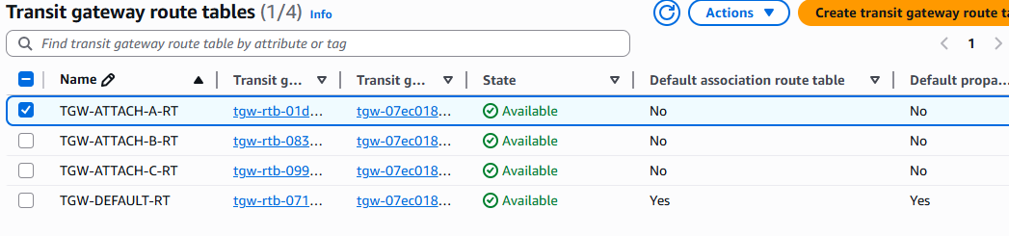

Create propagation from VPC-A to VPC-B

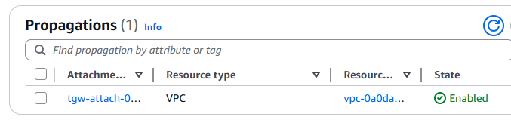

Similarly, from VPC-B to both VPC-A and VPC-C

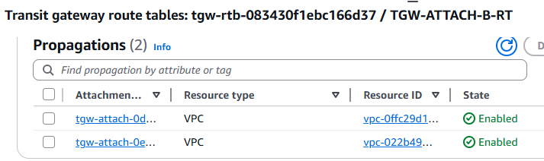

From VPC-C to VPC B

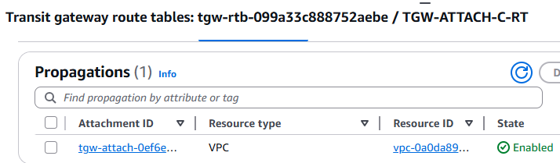

So we have not added propagation from VPC-A to VPC-C, Ideally communication should not work between them, lets validate it.

A to B

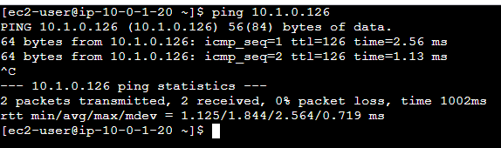

A to C

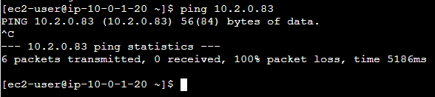

B to A

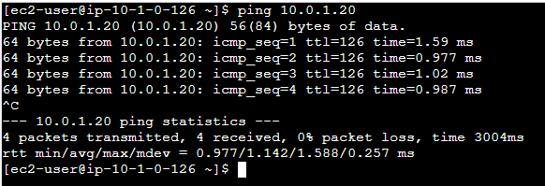

B to C

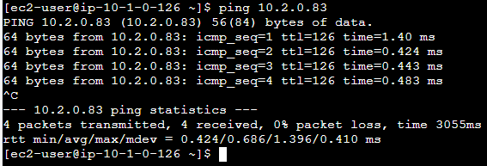

C to A

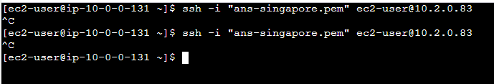

------------------------------------------------------------------------------------------------------------------

#### Cross-Region, Cross-Account Transit Gateway Peering

**Prerequisites**

**Account A (us-east-1)**:

* Multiple VPCs already connected to Transit Gateway
* Transit Gateway already created and operational

**Account B (eu-west-1)**:

* 2 VPCs already connected to Transit Gateway
* Transit Gateway already created and operational

**Requirements**:

* Non-overlapping CIDR blocks between all VPCs
* Appropriate IAM permissions in both accounts
* Transit Gateway IDs from both accounts

**Phase 1: Prepare Information**

**Step 1: Gather Required Information**

**In Account A (us-east-1)**:

1. Go to VPC Console → Transit Gateways
2. Note down the Transit Gateway ID (e.g., tgw-xxxxxxxxx)
3. Note down the AWS Account ID

**In Account B (eu-west-1)**:

1. Go to VPC Console → Transit Gateways
2. Note down the Transit Gateway ID (e.g., tgw-yyyyyyyyy)
3. Note down the AWS Account ID

**Step 2: Verify CIDR Blocks**

Ensure no overlapping CIDR blocks exist between:

* All VPCs in Account A (us-east-1)
* All VPCs in Account B (eu-west-1)

**Phase 2: Create Peering Connection**

**Step 3: Create Peering Attachment (Account A - Requestor)**

**In Account A (us-east-1)**:

1. Go to **VPC Console** → **Transit Gateways** → **Transit Gateway Attachments**
2. Click **Create transit gateway attachment.**
3. Select **Peering Connection** as attachment type
4. Configure:
   * **Transit gateway ID**: Select your TGW in us-east-1
   * **Account**: Select **Another account**
   * **Account ID**: Enter Account B's AWS Account ID
   * **Region**: Select **eu-west-1**
   * **Transit gateway ID (accepter)**: Enter Account B's TGW ID
5. Add tags (optional but recommended):
   * Name: TGW-Peering-US-to-EU
6. Click **Create transit gateway attachment.**

**Step 4: Accept Peering Request (Account B - Acceptor)**

**In Account B (eu-west-1)**:

1. Go to **VPC Console** → **Transit Gateways** → **Transit Gateway Attachments**
2. You should see a pending peering attachment with status **Pending Acceptance**
3. Select the peering attachment.
4. Click **Actions** → **Accept transit gateway attachment.**
5. Confirm the acceptance.

**Wait for Status**: Both attachments should show **Available** status (may take 2-5 minutes)

**Phase 3: Configure Routing**

**Step 5: Add Routes in Account A (us-east-1)**

**For each VPC that needs to communicate with Account B**:

1. Go to **VPC Console** → **Transit Gateways** → **Transit Gateway Route Tables**
2. Select the route table associated with your VPCs.
3. Click **Routes** Tab **Create route**
4. Configure:
   * **Destination CIDR block**: Enter CIDR blocks of VPCs in Account B (eu-west-1)
   * **Attachment**: Select the peering attachment you created
5. Click **Create route.**
6. Repeat for each VPC CIDR in Account B

**Step 6: Add Routes in Account B (eu-west-1)**

**For each VPC that needs to communicate with Account A**:

1. Go to **VPC Console** → **Transit Gateways** → **Transit Gateway Route Tables**
2. Select the route table associated with your VPCs.
3. Click **Routes** Tab **Create route**
4. Configure:
   * **Destination CIDR block**: Enter CIDR blocks of VPCs in Account A (us-east-1)
   * **Attachment**: Select the peering attachment
5. Click **Create route.**
6. Repeat for each VPC CIDR in Account A

**Phase 4: Update VPC Route Tables**

**Step 7: Update VPC Route Tables in Account A**

**For each VPC subnet that needs cross-region communication**:

1. Go to **VPC Console** → **Route Tables**
2. Select the route table for your subnet.
3. Click **Routes** tab → **Edit routes** → **Add route.**
4. Configure:
   * **Destination**: CIDR blocks of VPCs in Account B
   * **Target**: Select your Transit Gateway
5. Save changes.
6. Repeat for all relevant subnets.

**Step 8: Update VPC Route Tables in Account B**

**For each VPC subnet that needs cross-region communication**:

1. Go to **VPC Console** → **Route Tables**
2. Select the route table for your subnet.
3. Click **Routes** tab → **Edit routes** → **Add route.**
4. Configure:
   * **Destination**: CIDR blocks of VPCs in Account A
   * **Target**: Select your Transit Gateway
5. Save changes.
6. Repeat for all relevant subnets.

**Phase 5: Configure Security Groups**

**Step 9: Update Security Groups in Both Accounts**

**In Account A**:

1. Go to **EC2 Console** → **Security Groups**
2. For each security group that needs cross-region access:
   * Add inbound rules allowing traffic from Account B VPC CIDRs
   * Add outbound rules allowing traffic to Account B VPC CIDRs

**In Account B**:

1. Go to **EC2 Console** → **Security Groups**
2. For each security group that needs cross-region access:
   * Add inbound rules allowing traffic from Account A VPC CIDRs
   * Add outbound rules allowing traffic to Account A VPC CIDRs

**Phase 6: Testing and Verification**

**Step 10: Test Connectivity**

**From Account A (us-east-1)**:

1. Launch or access an EC2 instance in one of your VPCs.
2. Try to ping or connect to an instance in Account B (eu-west-1)
3. Use private IP addresses for testing.

**From Account B (eu-west-1)**:

1. Launch or access an EC2 instance in one of your VPCs.
2. Try to connect back to an instance in Account A (us-east-1)

**Step 11: Verify Route Propagation**

**Check Transit Gateway Route Tables**:

1. In both accounts, verify routes appear in TGW route tables.
2. Ensure peering attachment shows as **Available.**
3. Check VPC route tables have correct entries.

**Important Considerations**

**Cost**: Inter-region data transfer charges apply for traffic between regions

**Security**:

* Traffic is encrypted and stays on AWS backbone.
* Update NACLs if you use them.
* Consider least privilege security group rules.

**DNS**: Private DNS resolution does not work across regions through TGW peering.

**Monitoring**: Set up CloudWatch metrics to monitor cross-region traffic

**ASN**: Use unique ASNs for each Transit Gateway for future route propagation capabilities.

This setup will enable full bidirectional communication between all VPCs in both accounts across the two regions while maintaining security and staying on the AWS private network.

------------------------------------------------------------------------------------------------------------------

#### Transit Gateway Connect Attachment with Virtual Appliance

**Architecture Overview**

**Setup**: Multiple VPCs connected to Transit Gateway + Virtual Appliance VPC using Connect attachment for dynamic routing via GRE tunnels and BGP.

**Prerequisites**

**Existing Infrastructure**:

* Transit Gateway with multiple VPCs already attached.
* Virtual appliance (SD-WAN, firewall, etc.) deployed in a separate VPC.
* Virtual appliance VPC already attached to Transit Gateway as standard VPC attachment.

**Requirements**:

* Virtual appliances must support GRE tunneling.
* Virtual appliances must support BGP routing protocol.
* Appropriate IAM permissions
* Non-overlapping CIDR blocks

**Phase 1: Prepare Virtual Appliance VPC**

**Step 1: Verify VPC Attachment (Transport Attachment)**

**In AWS Console**:

1. Go to **VPC Console** → **Transit Gateways** → **Transit Gateway Attachments**
2. Verify your virtual appliance VPC is attached to Transit Gateway
3. Note the **Attachment ID** (e.g., tgw-attach-xxxxxxxxx) - this will be your **transport attachment.**
4. Ensure attachment status is **Available.**

**Step 2: Gather Virtual Appliance Information**

**Document the following**:

* Virtual appliance private IP address (ENI IP)
* Virtual appliance subnet CIDR
* BGP ASN, you want to use for the appliance (must be unique)
* Available /29 CIDR block from 169.254.0.0/16 range for BGP peering.

**Phase 2: Create Connect Attachment**

**Step 3: Create Transit Gateway Connect Attachment**

**In AWS Console**:

1. Go to **VPC Console** → **Transit Gateways** → **Transit Gateway Attachments**
2. Click **Create transit gateway attachment.**
3. Configure attachment:
   * **Transit gateway ID**: Select your Transit Gateway
   * **Attachment type**: Select **Connect**
   * **Transport attachment ID**: Select the VPC attachment of your virtual appliance VPC.
4. Add tags (recommended):
   * Name:

TGW-Connect-Virtual Appliance

1. Click **Create transit gateway attachment.**
2. Wait for status to become **Available.**

**Phase 3: Create Connect Peers (GRE Tunnels)**

**Step 4: Create First Connect Peer**

**In AWS Console**:

1. Go to **VPC Console** → **Transit Gateways** → **Transit Gateway Connect Peers**
2. Click **Create Transit Gateway Connect peer.**
3. Configure first peer:
   * **Transit Gateway Connect attachment ID**: Select the Connect attachment created in Step 3
   * **Peer GRE address**: Enter virtual appliance private IP address.
   * **BGP ASN**: Enter your appliance BGP ASN (e.g., 65001)
   * **Inside CIDR blocks**: Enter /29 block (e.g., 169.254.100.0/29)
4. Add tags:
   * Name:

TGW-Connect-Peer-1

1. Click **Create Connect peer.**

**Step 5: Create Second Connect Peer (For Redundancy)**

**Repeat Step 4 with different parameters**:

* **Inside CIDR blocks**: Use different /29 block (e.g., 169.254.101.0/29)
* **Name**:

TGW-Connect-Peer-2

**Note**: Both peers use the same appliance IP and ASN but different BGP addressing

**Phase 4: Configure Virtual Appliance**

**Step 6: Configure GRE Tunnels on Virtual Appliance**

**For each Connect peer, configure GRE tunnel**:

**Tunnel 1 Configuration**:

|  |
| --- |
| Interface: tunnel1 |
| Source: <appliance-private-ip> |
| Destination: <tgw-connect-peer-1-address> # From AWS console |
| Tunnel IP: 169.254.100.1/29 # First IP from your /29 block. |

**Tunnel 2 Configuration**:

|  |
| --- |
| Interface: tunnel2 |
| Source: <appliance-private-ip> |
| Destination: <tgw-connect-peer-2-address> # From AWS console |
| Tunnel IP: 169.254.101.1/29 # First IP from your second /29 block. |

**Step 7: Configure BGP on Virtual Appliance**

**For each tunnel, configure BGP session**:

**BGP Session 1**:

|  |
| --- |
| Router BGP <your-asn> |
| Neighbor 169.254.100.2 remote-as 64512 # AWS side ASN is always 64512. |
| Neighbor 169.254.100.2 activate. |

**BGP Session 2**:

|  |
| --- |
| Router BGP <your-asn> |
| Neighbor 169.254.101.2 remote-as 64512 |
| Neighbor 169.254.101.2 activate. |

**Step 8: Configure Route Advertisement**

**Advertise routes you want to share**:

|  |
| --- |
| Router BGP <your-asn> |
| Network <vpc-cidr-blocks> # Advertise VPC CIDRs you want reachable. |
| Network <on-premises-cidrs> # If connecting to on-premises. |

**Phase 5: Configure Transit Gateway Routing**

**Step 9: Associate Connect Attachment with Route Table**

**In AWS Console**:

1. Go to **VPC Console** → **Transit Gateways** → **Transit Gateway Route Tables**
2. Select the route table used by your VPCs.
3. Click **Associations** tab → **Create association.**
4. Select your **Connect attachment.**
5. Click **Create Association.**

**Step 10: Enable Route Propagation**

**In same route table**:

1. Click **Propagations** tab → **Create propagation.**
2. Select your **Connect attachment.**
3. Click **Create propagation.**

**This allows**:

* Routes advertised via BGP from appliance to be automatically added to TGW route table.
* VPCs to learn routes to networks behind the appliance.

**Phase 6: Configure VPC Route Tables**

**Step 11: Update VPC Route Tables**

**For each VPC that needs to communicate through the appliance**:

1. Go to **VPC Console** → **Route Tables**
2. Select route table for your VPC subnets.
3. Click **Routes** tab → **Edit routes** → **Add route.**
4. Configure routes for networks behind appliance:
   * **Destination**: CIDR blocks reachable through appliance
   * **Target**: Select your Transit Gateway
5. Save changes.

**Phase 7: Configure Security and Access**

**Step 12: Update Security Groups**

**For virtual appliance security group**:

1. **Inbound rules**:
   * Allow GRE (Protocol 47) from Transit Gateway ENI IPs
   * Allow BGP (TCP 179) from 169.254.100.2 and 169.254.101.2
   * Allow traffic from VPC CIDRs as needed.
2. **Outbound rules**:
   * Allow GRE (Protocol 47) to Transit Gateway ENI IPs
   * Allow BGP (TCP 179) to 169.254.100.2 and 169.254.101.2
   * Allow traffic to destination networks.

**For other VPC security groups**:

* Add rules to allow traffic to/from networks behind the appliance.

**Step 13: Configure NACLs (if used)**

**Update Network ACLs** to allow:

* GRE traffic (Protocol 47)
* BGP traffic (TCP 179)
* Application traffic as needed.

**Phase 8: Testing and Verification**

**Step 14: Verify BGP Sessions**

**Check BGP status on virtual appliance**:

|  |
| --- |
| # Example commands (varies by appliance) |
| show bgp summary |
| show bgp neighbors |
| show ip route bgp |

Run in CloudShell

**In AWS Console**:

1. Go to **VPC Console** → **Transit Gateway Connect Peers**
2. Check **BGP Status** should show **UP**

**Step 15: Verify Route Propagation**

**Check Transit Gateway route table**:

1. Go to **VPC Console** → **Transit Gateway Route Tables**
2. Click **Routes** tab
3. Verify routes from appliance appear with Connect attachment as target

**Step 16: Test Connectivity**

**From VPC instances**:

1. Test connectivity to networks behind virtual appliance
2. Verify traffic flows through appliance (check appliance logs/monitoring)
3. Test return traffic

**Important Considerations**

**Performance**:

* Maximum 5 Gbps per GRE tunnel
* Use multiple Connect peers for higher bandwidth
* Maximum 4 Connect peers per Connect attachment

**Routing**:

* Connect attachments only support dynamic routing (BGP)
* No static routes supported
* Use route priorities and AS-path prepending for traffic engineering

**Redundancy**:

* Always configure at least 2 BGP sessions per Connect peer
* Consider multiple Connect peers for redundancy
* Monitor BGP session health

**MTU Considerations**:

* GRE adds 24-byte overhead
* Set GRE tunnel MTU to interface MTU minus 44 bytes (24 GRE + 20 IP)
* Typical: 1500 - 44 = 1456 bytes for GRE tunnel MTU

**Monitoring**:

* Set up CloudWatch metrics for Connect attachment
* Monitor BGP session status
* Track route advertisements and withdrawals

This setup enables dynamic routing between your VPCs and networks reachable through the virtual appliance, with automatic failover and load balancing capabilities.

------------------------------------------------------------------------------------------------------------------

#### AWS Site-to-Site VPN setup guide

Architecture



Steps:

Check for the document in the VPN section of the files

---------------------------------------------------------------------------------------------------------------------

#### AWS Client VPN

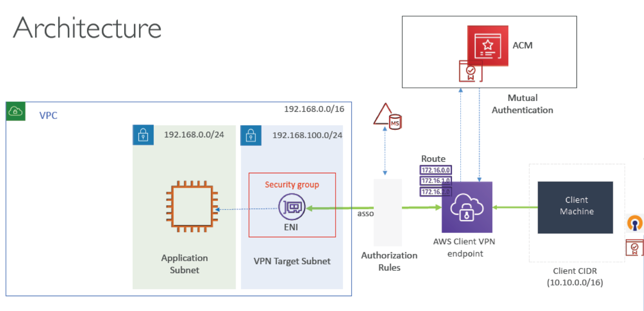

Before we create a client VPN we need to generate the client certificates/keys for mutual authentication.

[Client authentication in AWS Client VPN - AWS Client VPN](https://docs.aws.amazon.com/vpn/latest/clientvpn-admin/client-authentication.html)

As we are using a windows machine as client we will be following windows based steps.

[Enable mutual authentication for AWS Client VPN - AWS Client VPN](https://docs.aws.amazon.com/vpn/latest/clientvpn-admin/client-auth-mutual-enable.html)

Verify the certificates in ACM

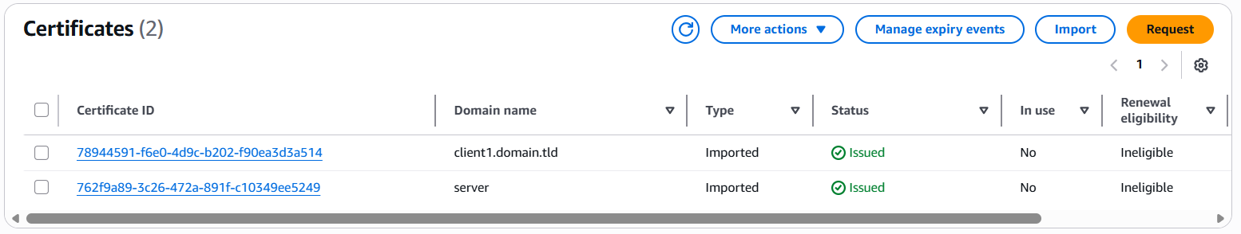

Now let us create the VPC as per architecture

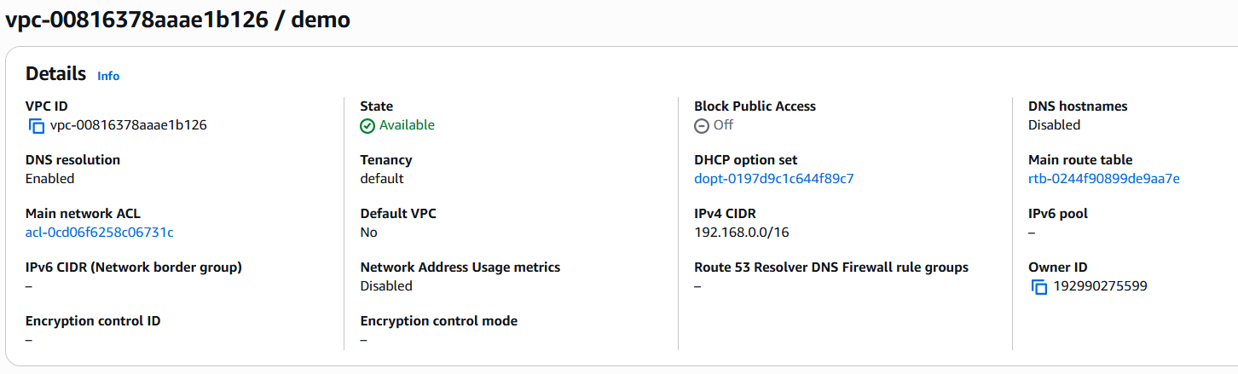

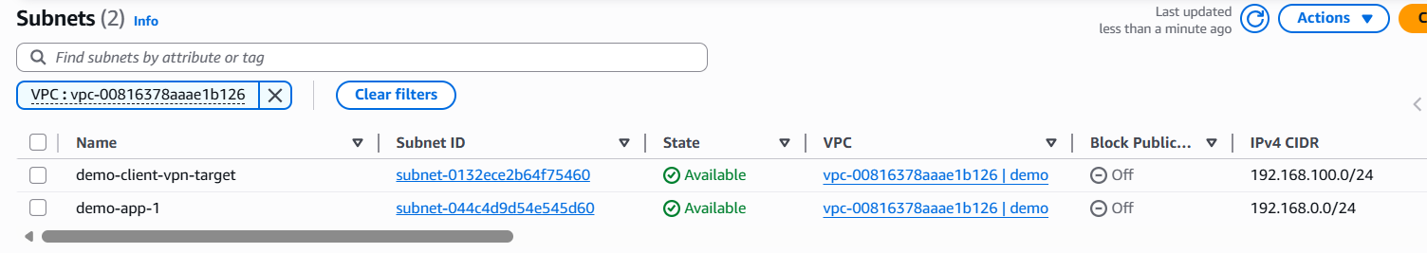

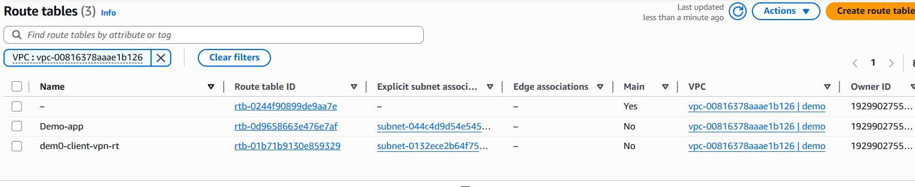

Create a SG for ENI for client vpn endpoint

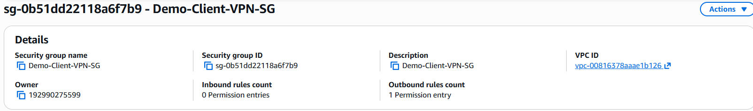

Launch an ec2 in app subnet and allow communication from eni of client vpn endpoint.

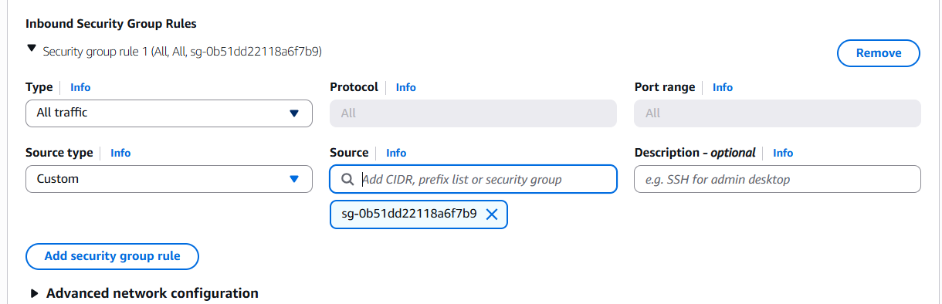

Create AWS Client VPN Endpoint

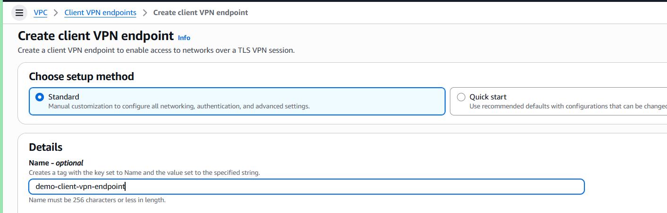

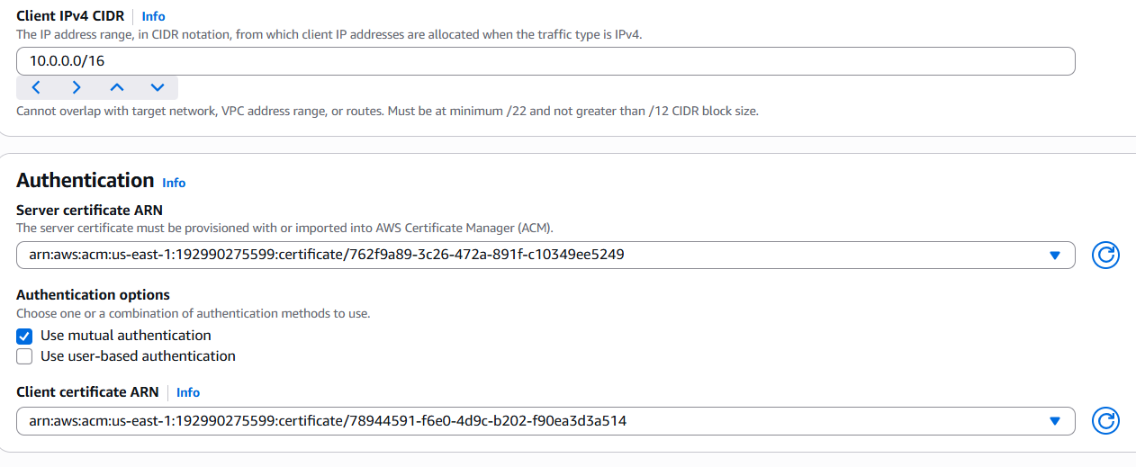

Click Create Client VPN Endpoint once its created it will show as pending association then we need to associate it with target network (subnet).

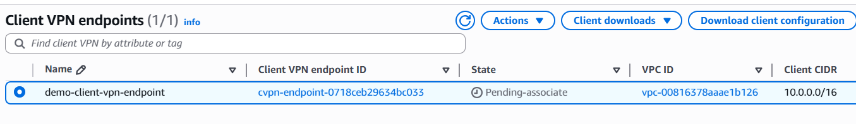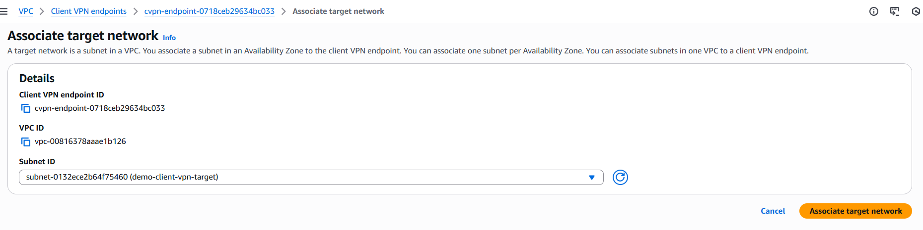

Create authorization rule

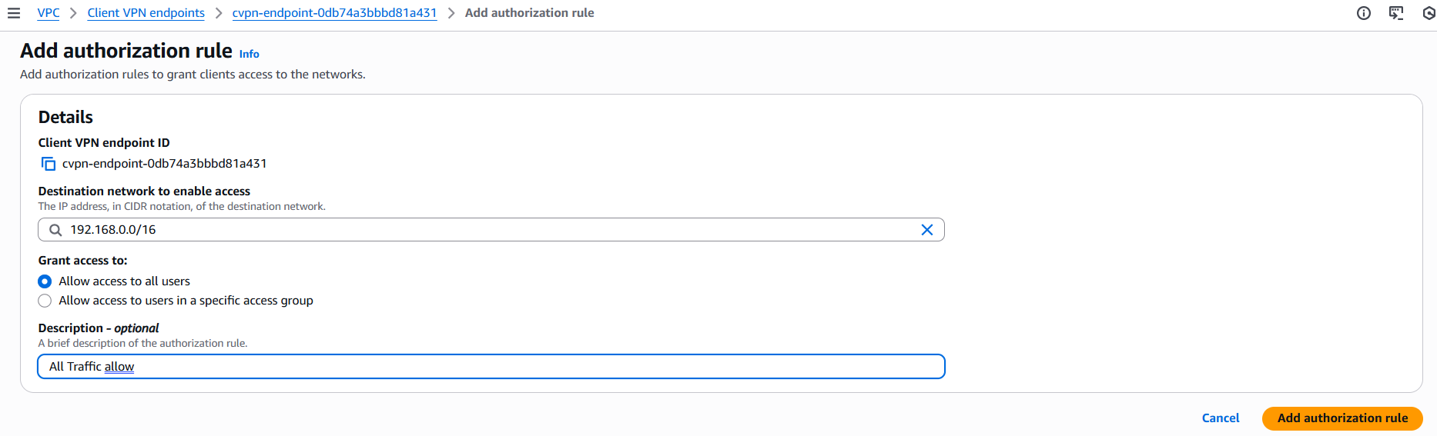

Once we add authorization rules AWS will automatically populate the routes to its route table

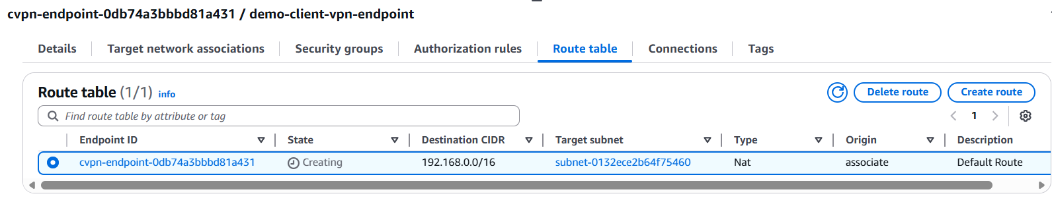

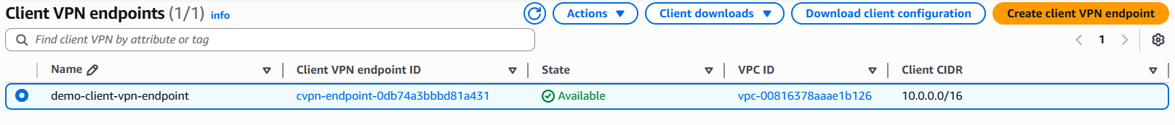

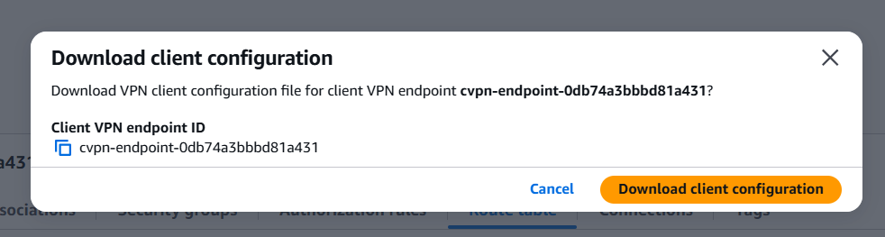

Now we have to modify it and add the certs path in it and modify dns (add xxxx)

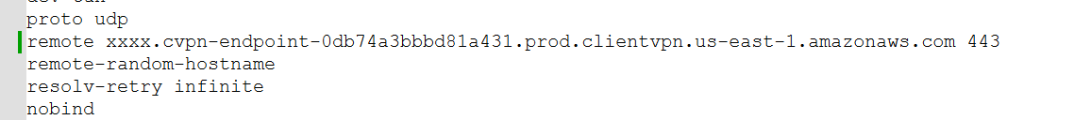

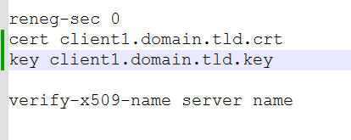

Import vpn config file to OpenVPN Client

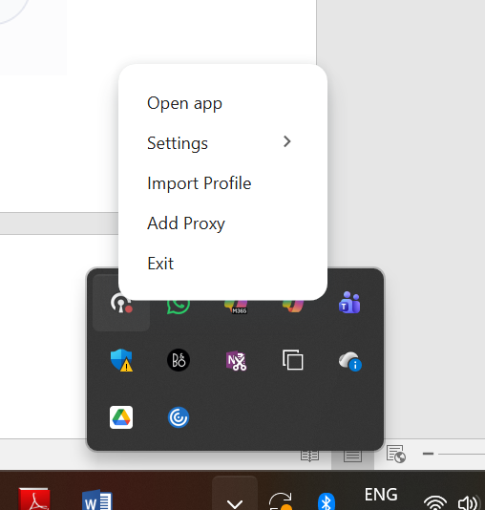

Select the file and import (make sure that the certs, keys and configurations are in same folder)

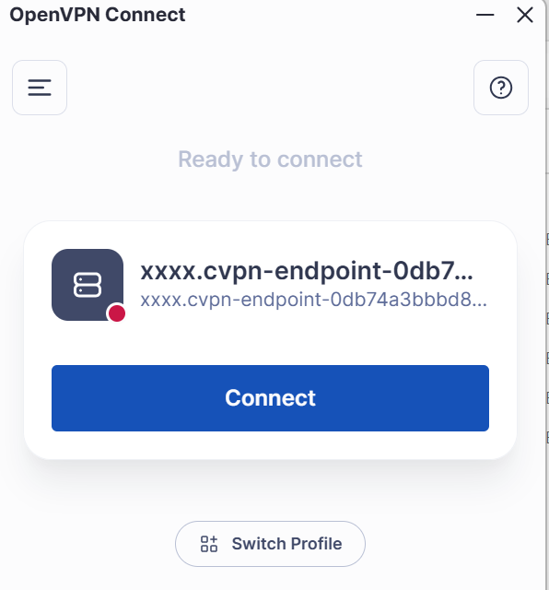

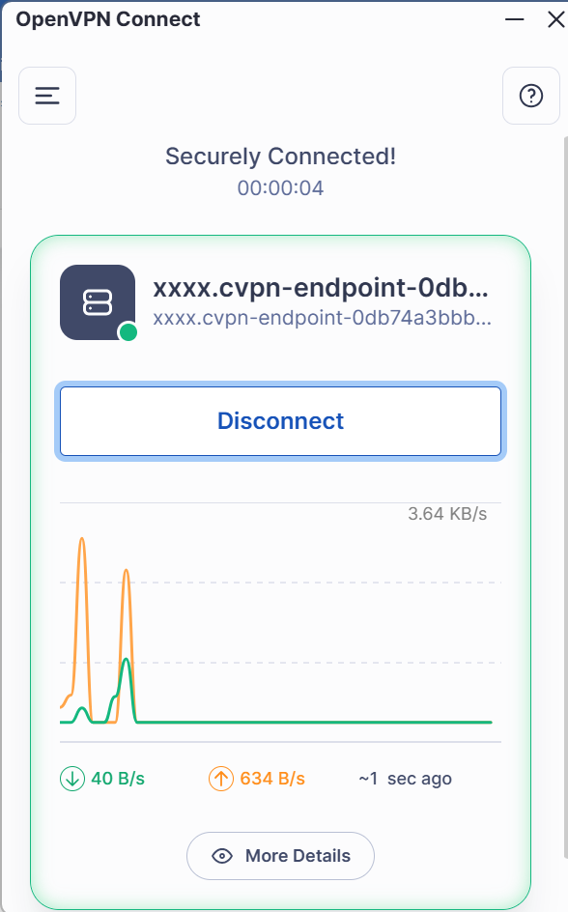

Check the ip config if we are getting ip form 10.0.0.0/16

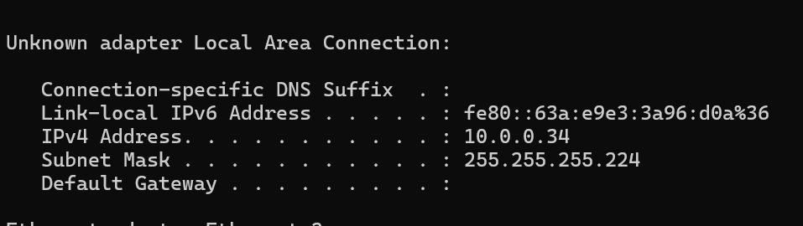

Ping the demo app instance created in demo vpc

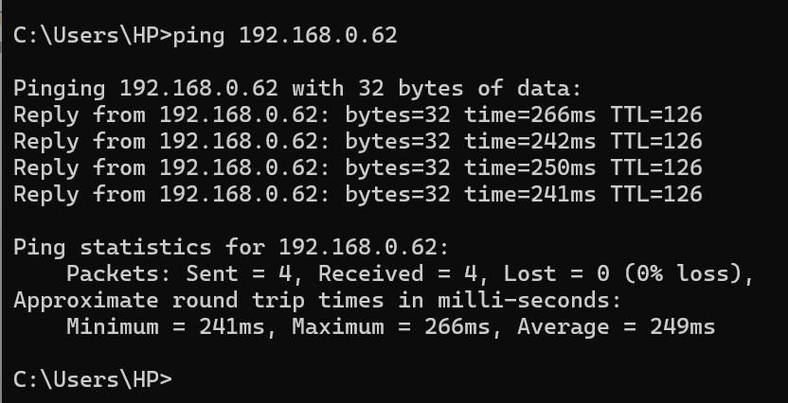

We are getting a response back, which means we are successfully connected to the VPC resources using Client VPN.

Try connecting to internet it does not work, as we have not allowed internet from VPC via CientVPN

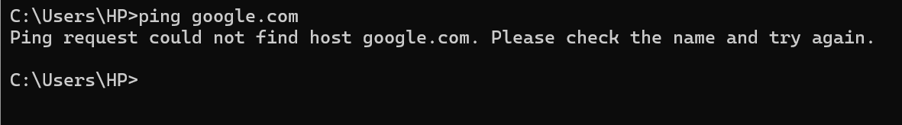

Create IGW and attach to VPC

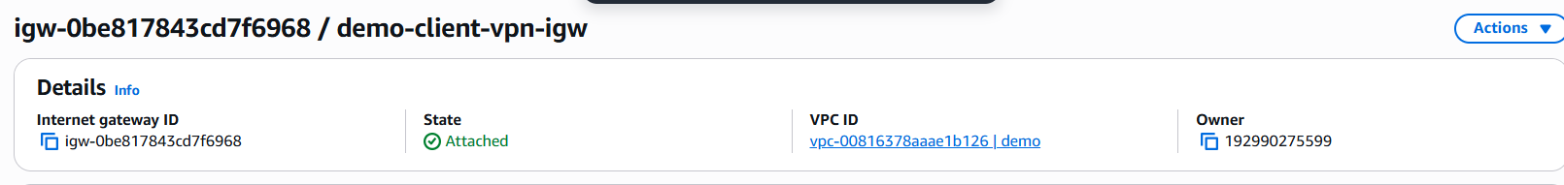

Add internet route entry in route table

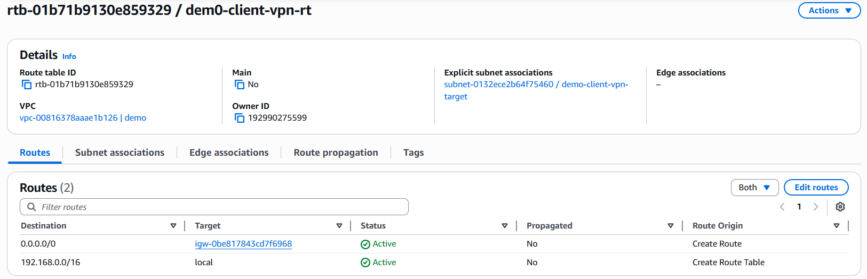

In the Client VPN endpoint authorization rules and route table add entry to internet traffic

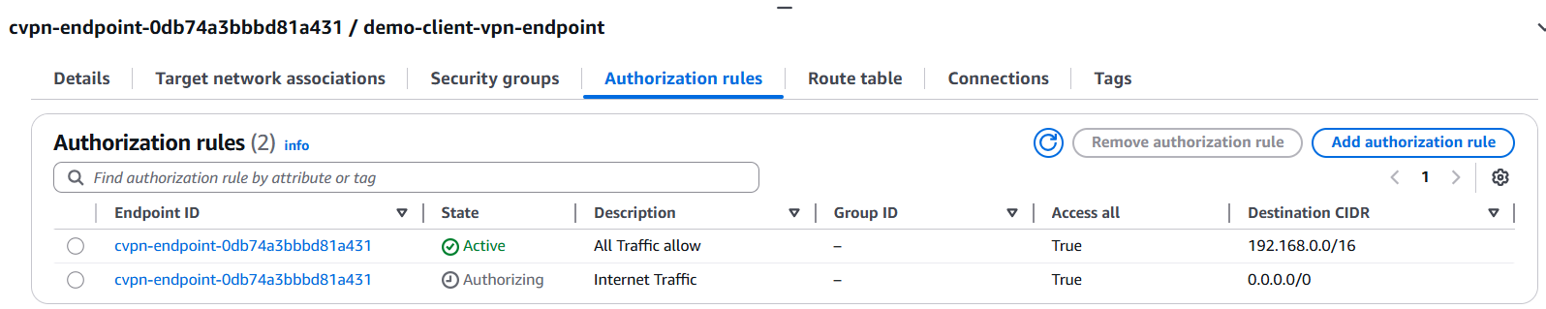

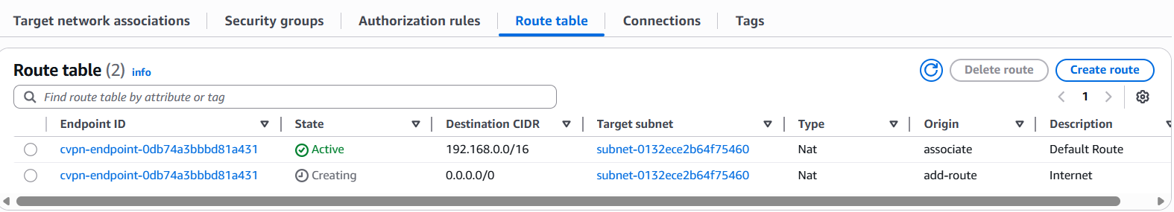

Now connect again to Client VPN and try accessing internet

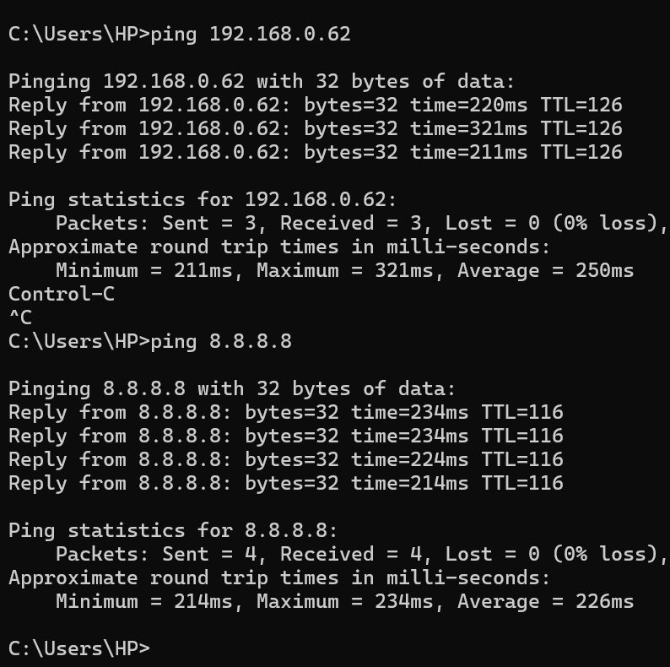

Connecting to Internet using Split Tunnel

Go to Client VPN endpoints and modify endpoint

Select the split tunnel

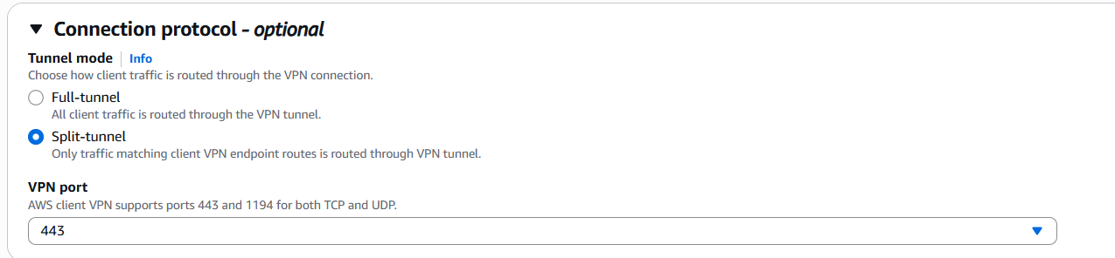

Remove authorization and route table route entry to internet

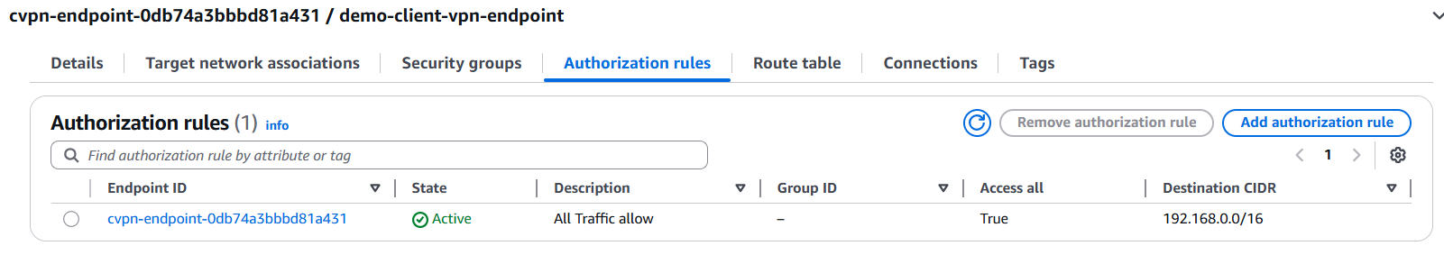

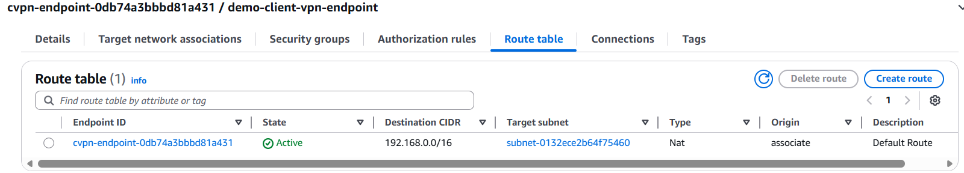

Now check the connectivity from local machine

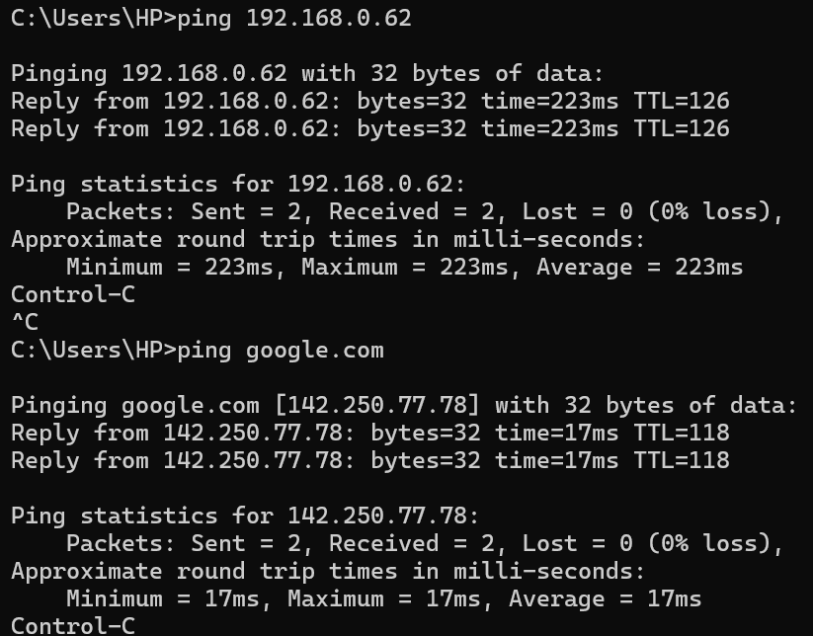

Similary we can also peer vpc connections.

We need to update route tables of subnets, authorization rules and client vpn route tables.